Intelligent Data Center ROC-A6 Monitoring Software System User Manual

Version1.0

all right reserved © Shenzhen Kuanpeng IoT Technology Co., Ltd.

Foreword

Welcome to use our technology products.

“Intelligent Data Center ROC-A6 Monitoring Software System User Manual

Version1.0 ”is the operation description of ROC-A6 monitoring host WEB system. The manual describes the addition, configuration and parameter setting of various front-end collectors and equipment, sound and optical alarm, SMS alarm, telephone alarm function setting, alarm time setting, log management, historical data query and other functions. This manual combines with a large number of drawings, intuitive and easy to understand, convenient for you to be familiar with and use the system, and the remote monitoring and management of the machine room.

This manual is prohibited from copying, quoting or printing without permission. Manual contents may change subject to software updates from the date of release without notice.

Before use, please read the instructions carefully, I believe it will be of great help to you to use the system effectively. Due to the short time, there are some shortcomings in this manual. If you find any problems, you are welcome to contact us in time.thanks.

**Disclaimer**

* This manual involves sensitive data such as system user name, camera address and unit name, please keep it properly and do not transfer it to those who have no right to use the system. The Company shall not assume any responsibility for the disclosure of information caused by the above misconduct.
* Software failure, hardware damage and network abnormality caused by failure to follow this manual are not within the service scope.
* When using this product, please strictly follow the applicable laws. The Company shall not be liable if the product is used in violation of the rights of third parties or other improper use.
* In case of any conflict between the contents of this manual and the applicable laws, the legal provisions shall prevail.

Shenzhen Kuanpeng IoT Technology Co., Ltd.

July 2024

catalogue

1. Basic Operation 2

1.1 Login 2

1.2 Main Interface 3

1.3 Navigation Bar Introduction 4

1.3.1 Monitoring Information Query 4

1.3.1.1 Temperature and Humidity Monitoring 4

1.3.1.2 Water leakage Monitoring 4

1.3.1.3 Advanced control 5

2. Log Query 6

2.1 History Data Query 6

2.2 Alarm Query 6

3. Configuration Options 8

3.1 Configuration Options 8

3.2 AI/DI Device 8

3.3 RS232 Device 9

3.4 RS485 Device 10

3.5 Network Devices 11

4. Device Configuration 13

4.1 Device Information 13

4.2 Support Model Management 13

4.3 User Management 14

4.4 Period Management 15

4.5 Access Control Management 15

4.6 Mailbox Configuration 16

4.7 Network Configuration 16

4.8 Resource Allocation 17

4.9 Application Management 18

4.10 Device Reboot 19

5. Maintenance Overhaul 20

5.1 Daily Inspection 20

5.2 Cyclic Check 20

5.2.1 Check every week 20

5.2.2 Monthly inspection 21

5.2.3 Monthly inspection 21

# Basic Operation

This chapter mainly explains some basic operations of the web system interface of intelligent Data Center.

## Login

Enter the host IP address in the browser address access bar of the local PC, press the enter key to login the power and environment monitoring system , as shown in the figure:



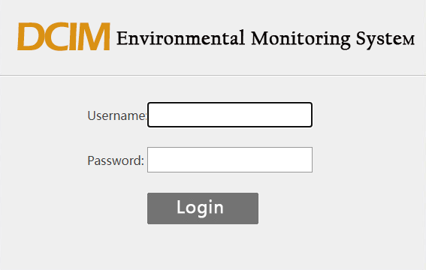

Enter the default user name: Admin, no password, and click the login button to log in to the system.After login to the system, the home page is shown in the figure:

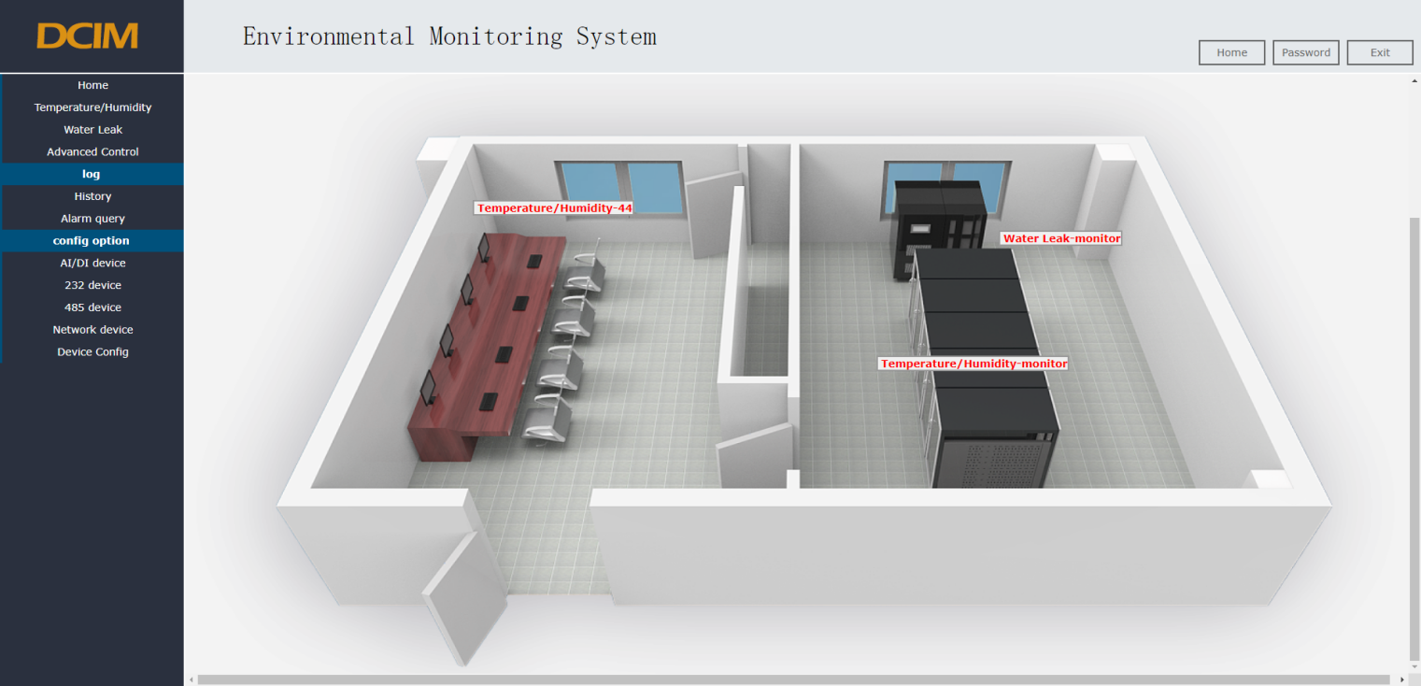

Figure 2. Home page of the system

The 3D diagram shows the position of each equipment in the machine room in the form of the 3D machine room map effect, which shows the real-time numerical status and the corresponding position of the corresponding equipment.

## Main Interface

The main interface is mainly divided into the following parts: company icon, system name, navigation menu bar, current system status, equipment monitoring information, password modification, and secure exit.as shown in the figure.

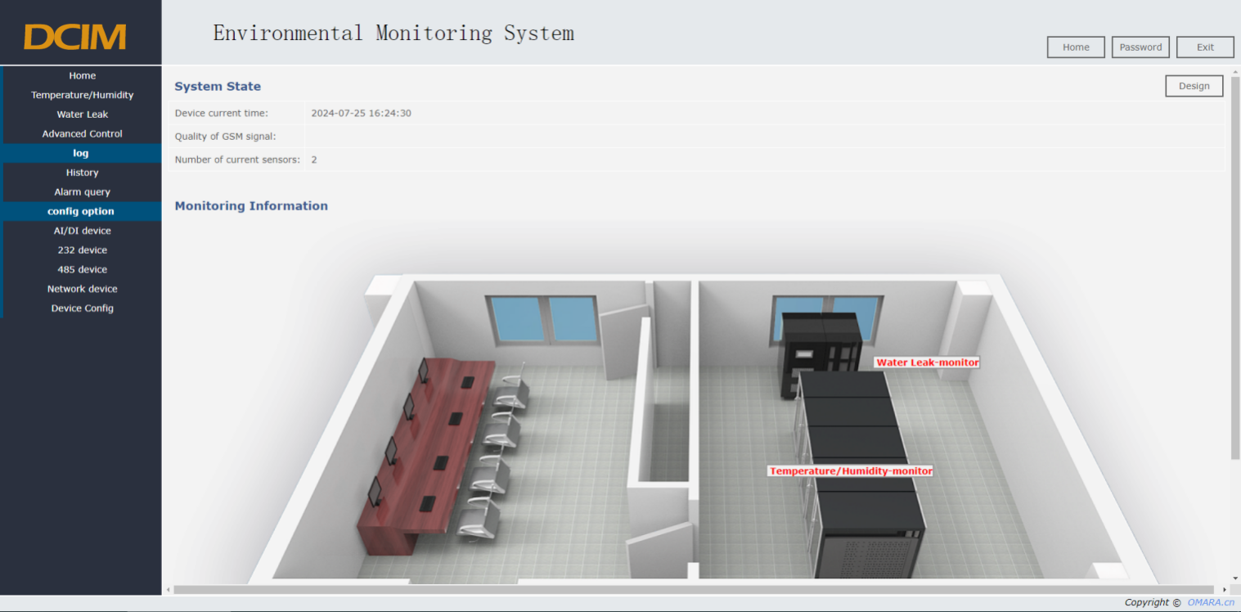

**Illustrate:**

* Company icon: Company LOGO icon
* System name: Monitoring system name
* Home : Click on to return to the home page
* Password: Click to change the password of the current account. The password format consists of numbers, letters and special characters, and the password length is 1 to 15 bits.
* Exit: Click to exit the system and return to the login page.
* Current status of system: including current time of system equipment and GSM signal quality.
* Navigation bar: all the equipment menu, click the corresponding name to view the monitoring details interface of all the devices, click the alarm record to view the current alarm information, click the alarm query to query the alarm information according to the conditions, click the configuration option configuration to realize the addition of new equipment.
* Equipment monitoring information: 3D diagram to display and view the status and information of the current monitoring equipment

## Navigation Bar Introduction

The navigation bar menu includes three modules: the monitoring device information, log, and configuration options.

* + 1. **Monitoring Information Query**

View the detailed monitoring items and configuration properties for the specific monitoring device.

* + - 1. **Temperature and Humidity Monitoring**

Mainly monitor the temperature value and humidity value parameters of the equipment room environment.

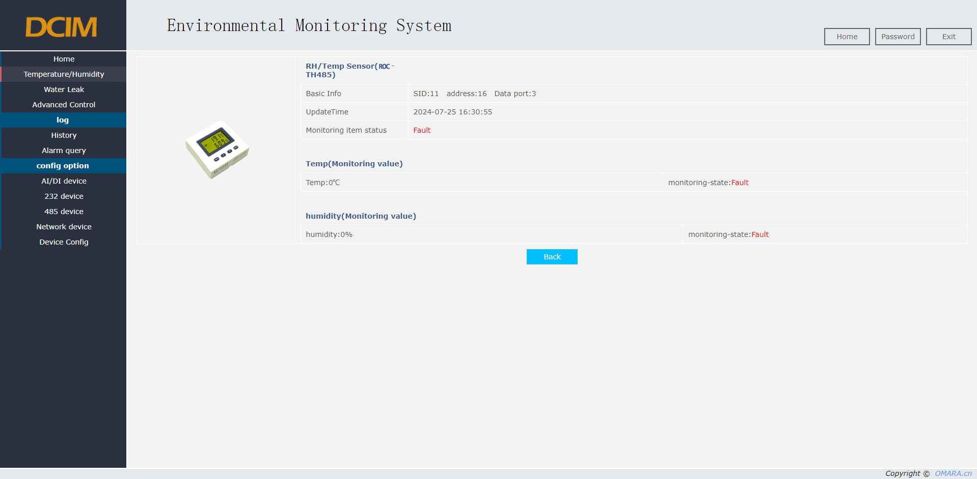

* + - 1. **Water leakage Monitoring**

The main monitoring room has air conditioning or inlet and outlet pipes and other equipment is prone to water leakage. Regional leakage monitoring method monitors the leakage situation in real time, and the system will automatically alarm when the leakage occurs.

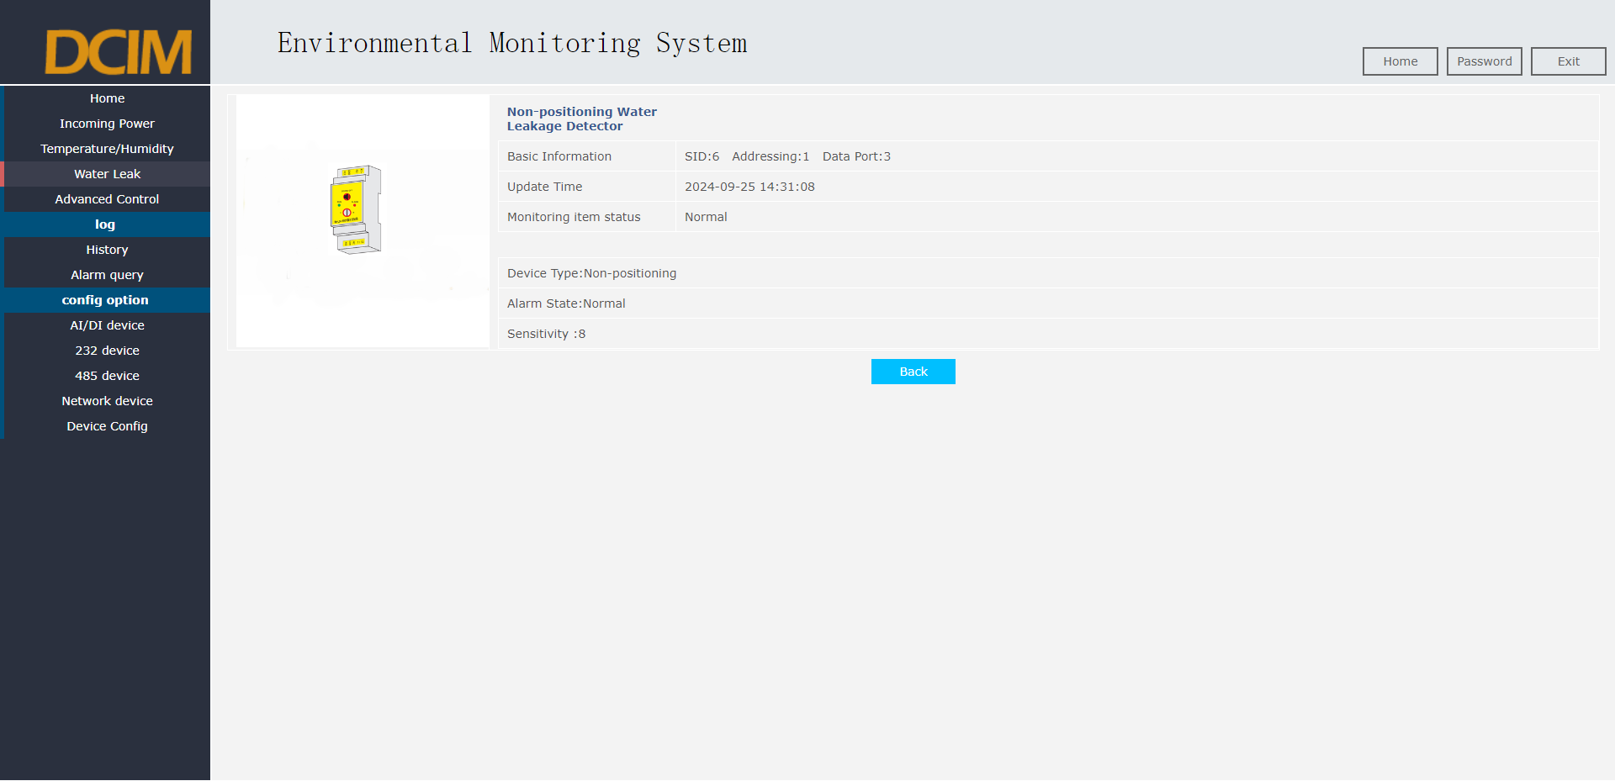

* + - 1. **Advanced control**

Advanced control can be linked or manually controlled to turn on and off external devices, such as lighting control and fan control.

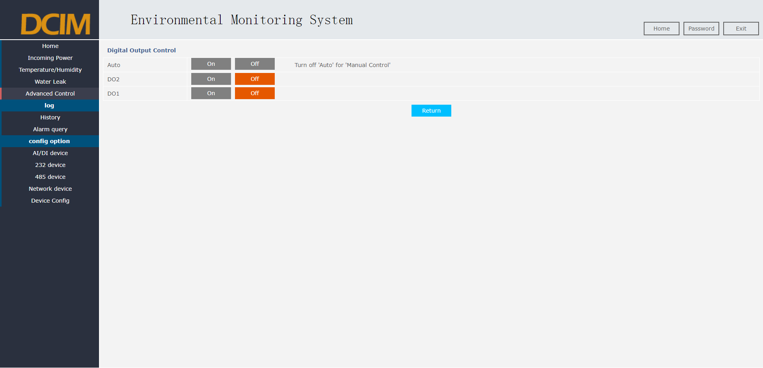

# Log Query

## History Data Query

Historical data query is the historical monitoring information query of sensor equipment.

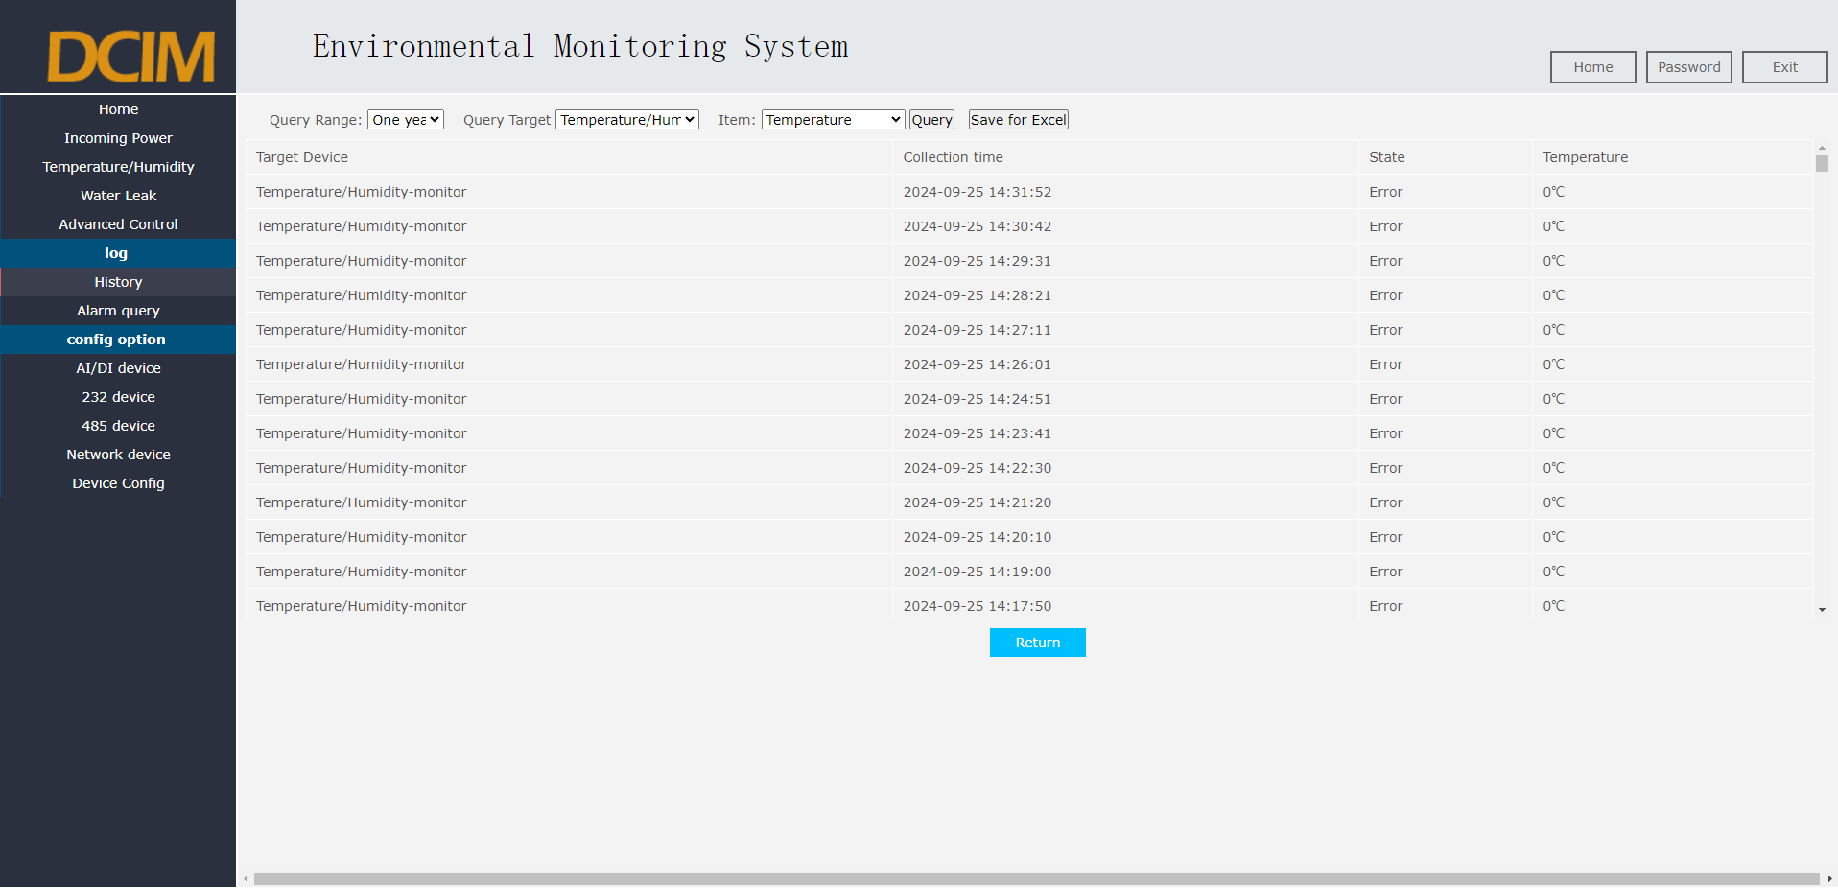

## Alarm Query

Users can query the alarm time, reason, mode, object, category, description and other information records of all current devices according to conditions such as time and category, and can export Excel reports for data comparison and saving.

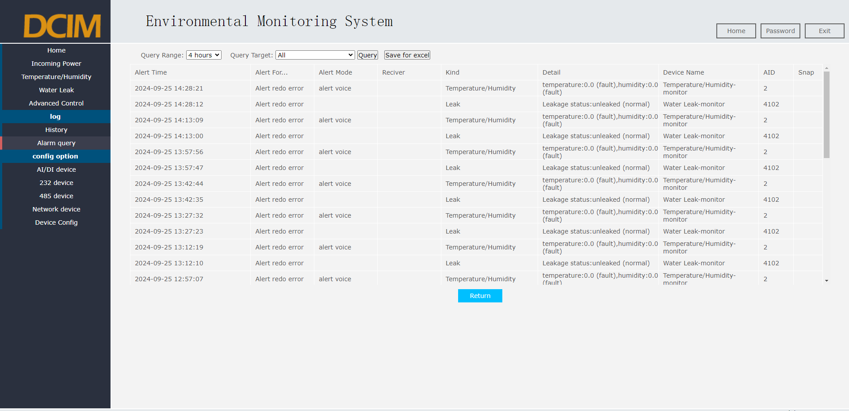

# Configuration Options

This chapter describes the addition of monitoring equipment and parameter modification in detail.

## Configuration Options

The expanded monitoring equipment of the monitoring system can complete the configuration operation online. The configuration options are divided into four types of equipment configuration, namely AI / DI equipment, 232 equipment, 485 equipment and network equipment.

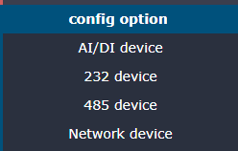

## AI/DI Device

1. AI / DI equipment includes water leakage detector, smoke detector, infrared detector, door magnetic, fire protection and other dry contact equipment and analog output equipment.
2. Add monitoring item: Select the sensor type corresponding to the added monitoring item, and click "Add item" to add the monitoring item. Here is an example of adding a "water leakage detector". Other sensors are added in a similar way.

* Select "water leakage detector" and click "Add item" to enter the intrusion sensor editing interface.
* Edit the basic settings, parameter settings, and alarm settings for the device in the editing interface.
* Click Save to complete the addition of the "water leakage detector" device.
* Restart the device, and the added monitoring device takes effect.

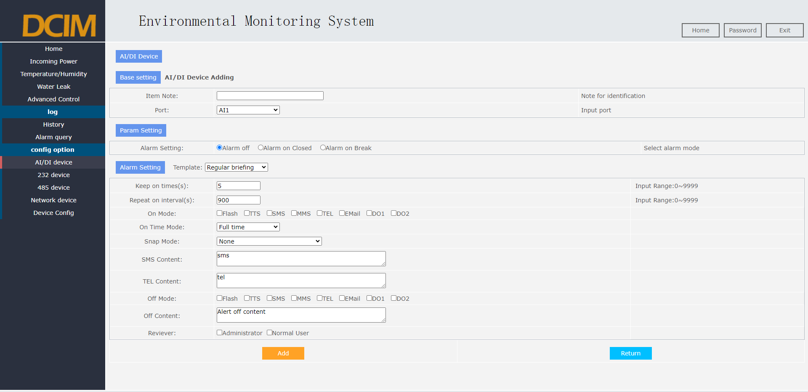

## RS232 Device

1. RS232 Equipment includes SMS phone alarm, moving ring touch screen and other devices.
2. Add monitoring item: Select the sensor type corresponding to add monitoring item, select the corresponding port number, and click "Add item" to complete the adding operation of monitoring item. The following to add "SMS phone alarm" as an example, other sensors to add a similar operation method.

* Select "SMS Phone Voice Module (ROC-B5)", select port "ttymxc1", click Add monitoring item, and add a SMS phone alarm.
* Click Edit to edit the basic settings, parameter settings and alarm settings of the device in the editing interface
* Click Save to complete the addition of the "SMS phone alarm" device
* Restart the device, and the added monitoring device takes effect

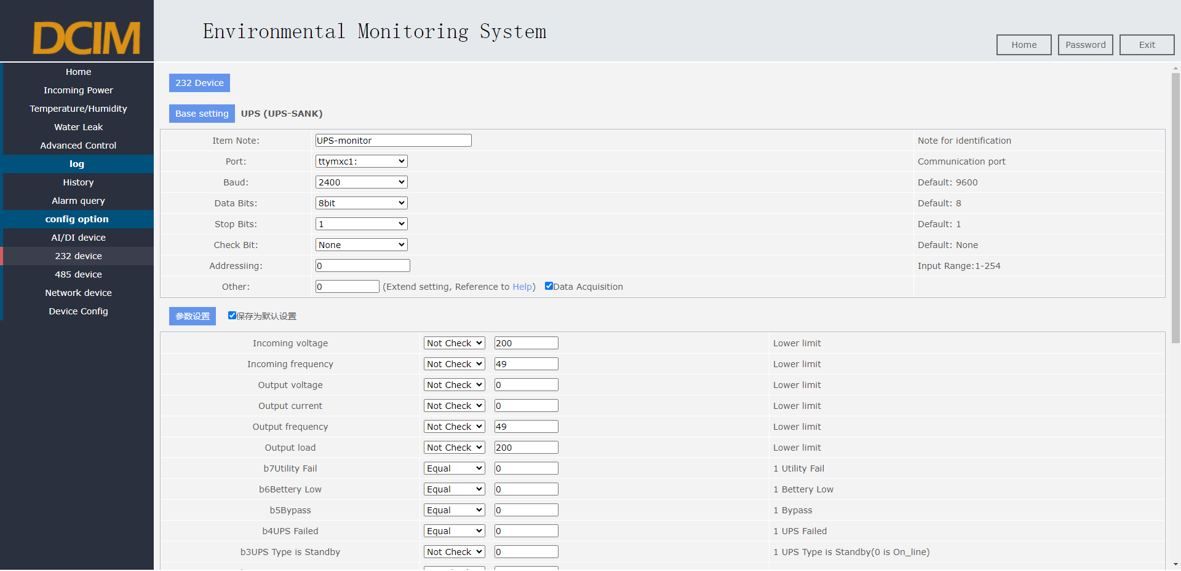

## RS485 Device

1. The RS485 equipment includes three-phase electric meter, distribution switch detector, battery monitoring module, temperature and humidity sensor and other equipment.
2. Add monitoring item: Select the sensor type corresponding to add monitoring item, select the corresponding port number, and click "Add item" to complete the adding operation of monitoring item. With the example of adding "temperature and humidity sensor", other sensors add similar operations.

* Select "Temperature and Humidity (ROC-TH-B801)", select port "RS485-1", click Add monitoring item, then add a temperature and humidity monitoring.
* Click Edit to edit the basic settings, parameter settings and alarm settings of the device in the editing interface
* Click Save to complete the "temperature and humidity sensor" device addition
* Restart the device, and the added monitoring device takes effect

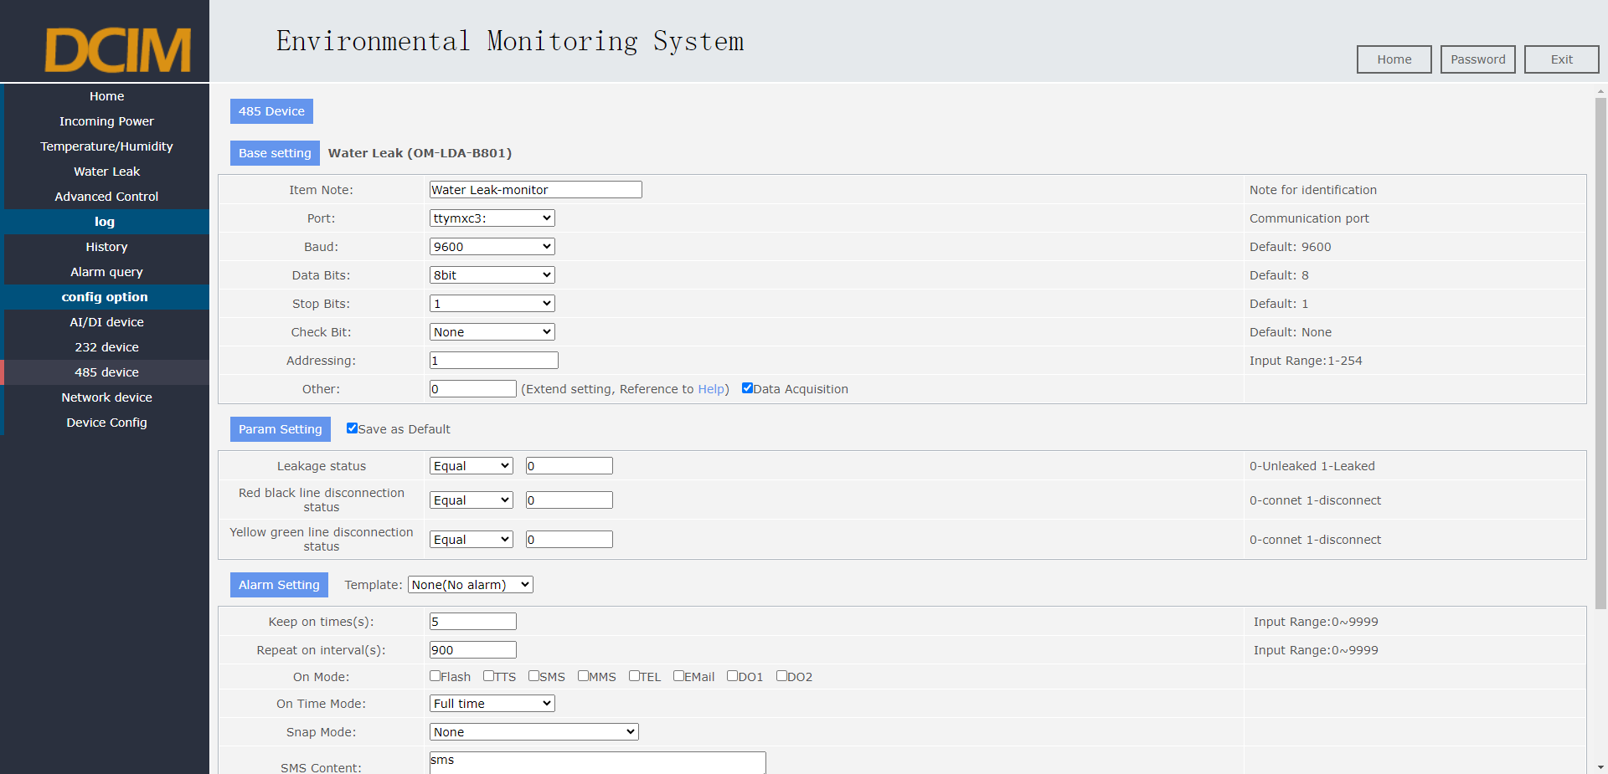

## Network Devices

1. Network equipment including access control system, serial port server and other equipment.
2. Add monitoring item: Select the sensor type corresponding to add monitoring item, select the corresponding port number, and click "Add item" to complete the adding operation of monitoring item. As an example of adding an "access control system", other sensors operate similarly.

* Select "Access Control IC Card (ROC-ICA100)", click Add monitoring item, then enter the editing interface.
* Edit the corresponding parameters for the device in the editing interface
* Click Save to complete the addition of the "access control system" equipment
* Restart the device, and the added monitoring device takes effect

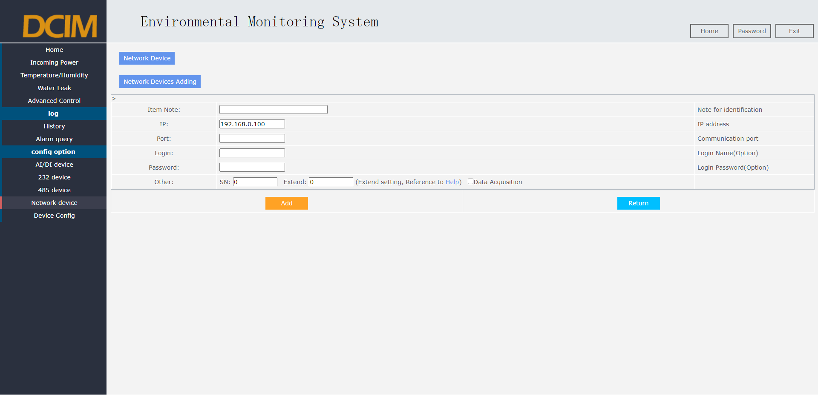

# Device Configuration

This section provides a basic explanation on the configuration of monitoring host.

## Device Information

1. Device information is the main device information, including the device name, device ID, HTTP, FTP, TELNET, IP, date and time, and the synchronization time.as shown in the figure
2. One-key synchronization time: the monitoring system time and the computer network time synchronization, click the synchronization time to achieve synchronization.

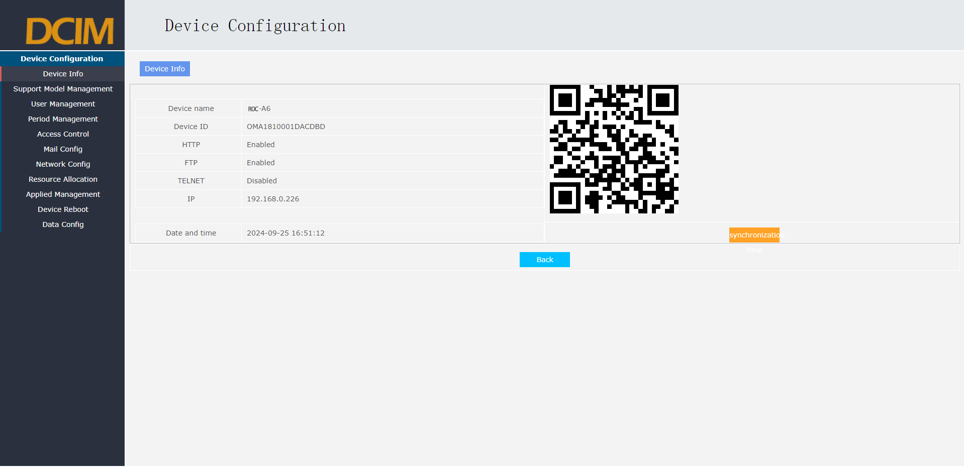

## Support Model Management

1. Support model management, display the model list of monitoring equipment connected to the system, including electrometer, UPS, battery detection module, precision air conditioning and other equipment.
2. The page adds the new access system to the new equipment including power meter, UPS, battery detection module, precision air conditioning, etc.

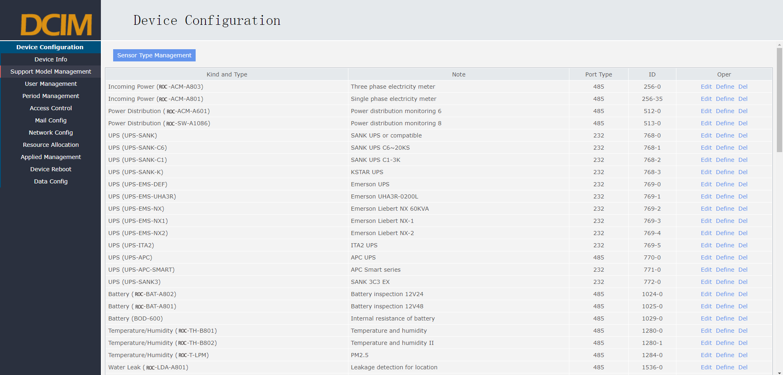

## User Management

1. User management is divided into two levels of permission: super administrator and ordinary users. It can add up to 16 users and support 16 users to access at the same time.
2. User management can edit the current user, including user name, user status, whether or not, management, SMS number, mobile phone number, user mailbox, and description.
3. Super users have the highest permissions, and can view and manage the system, modify the configuration, and add the operation of the monitored equipment.
4. Ordinary users can only view and browse the system, but cannot modify the configuration, add configuration and other operations.

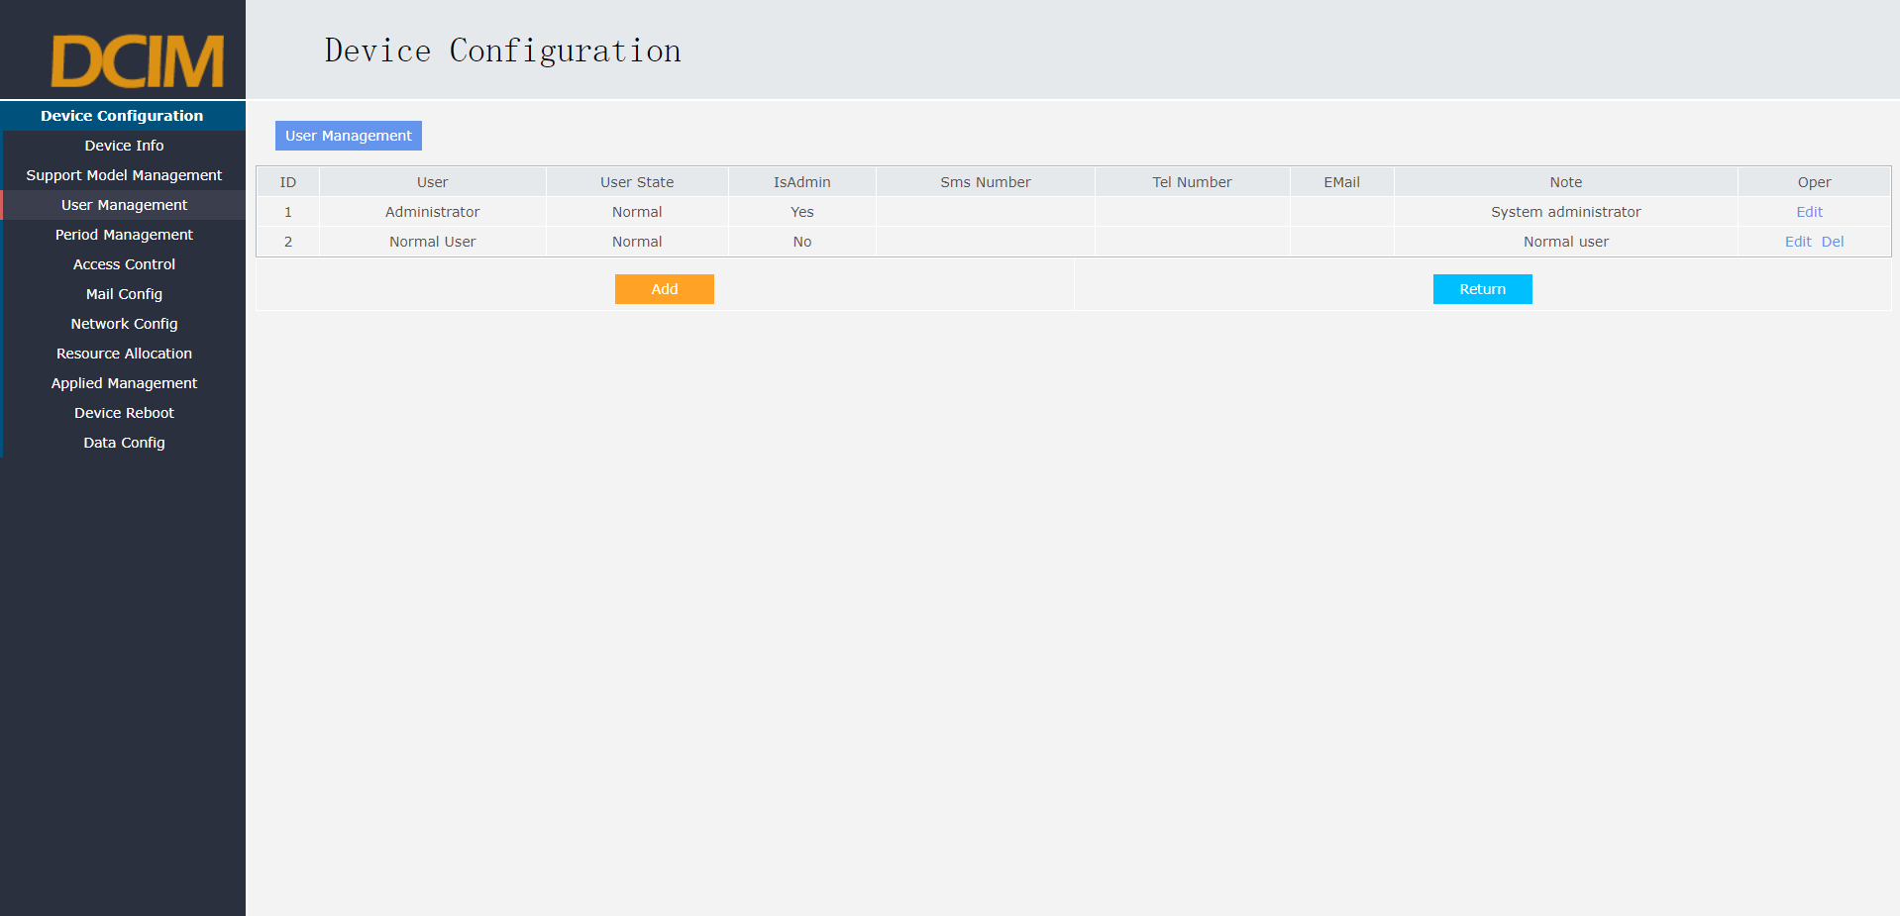

## Period Management

1. Period period management is mainly to configure the alarm time, which includes full time alarm, working time alarm, Saturday and Sunday alarm, and custom time period.
2. Full time alarm: 7*24 hours full time alarm.
3. Alarm during working hours: 8:00 to 18:00 / default from Monday to Friday, not on weekends.
4. Alarm on Saturday and Sunday: default on Saturday and Sunday, not on weekdays.
5. Custom time period: the user-defined alarm time period.

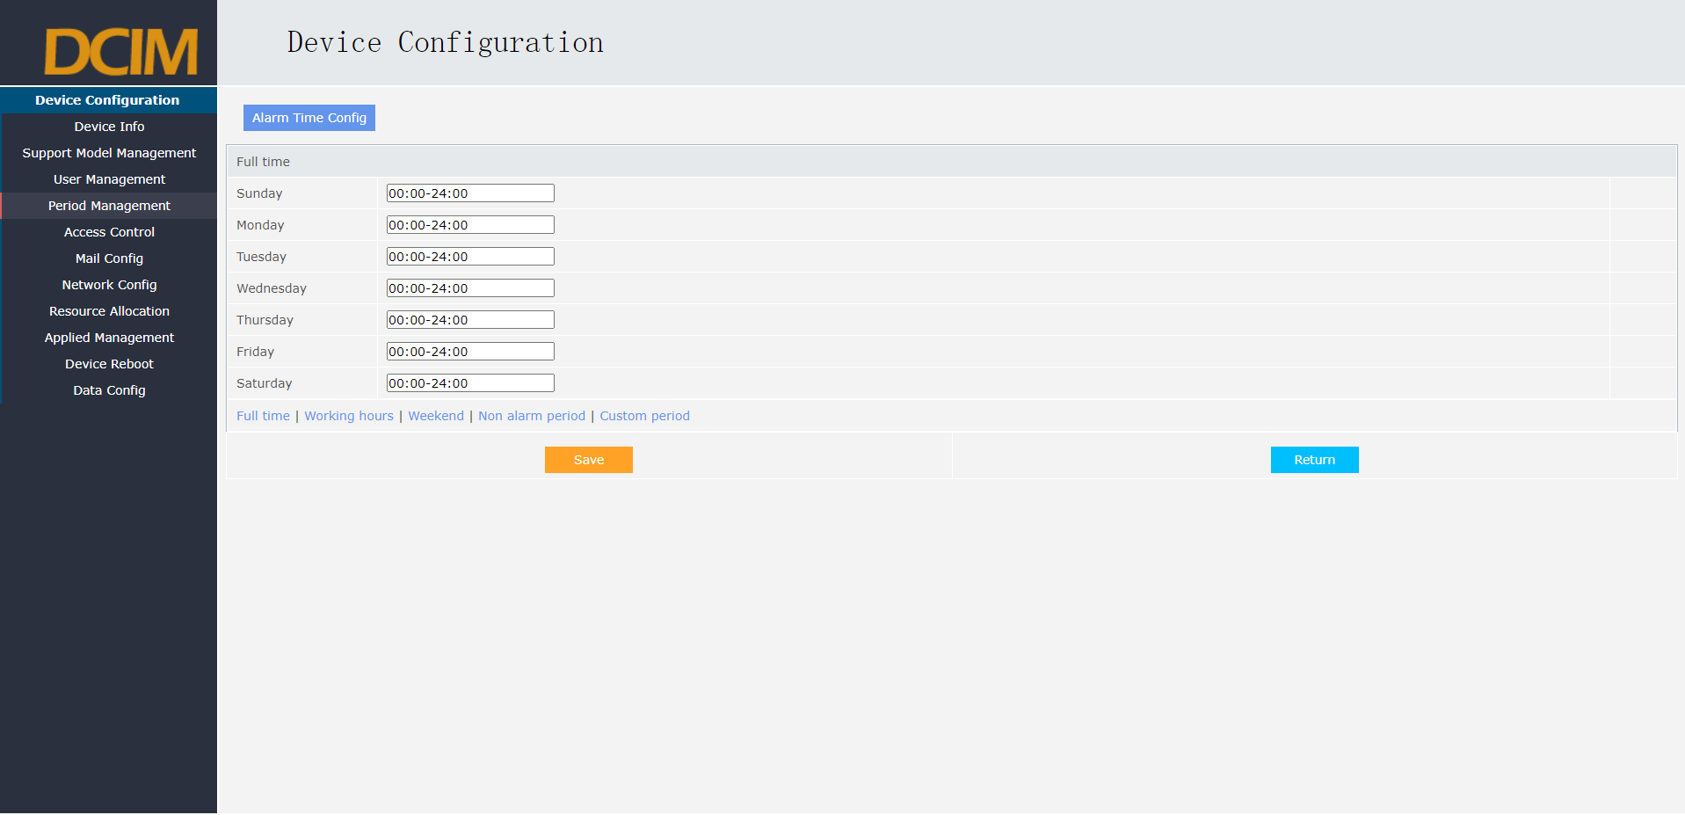

## Access Control Management

1. Access control management is to note the name of the current access control card number to query the access control personnel in the machine room.
2. The page can set the card number, name, description to increase, update, delete, and can be checked through the card number.

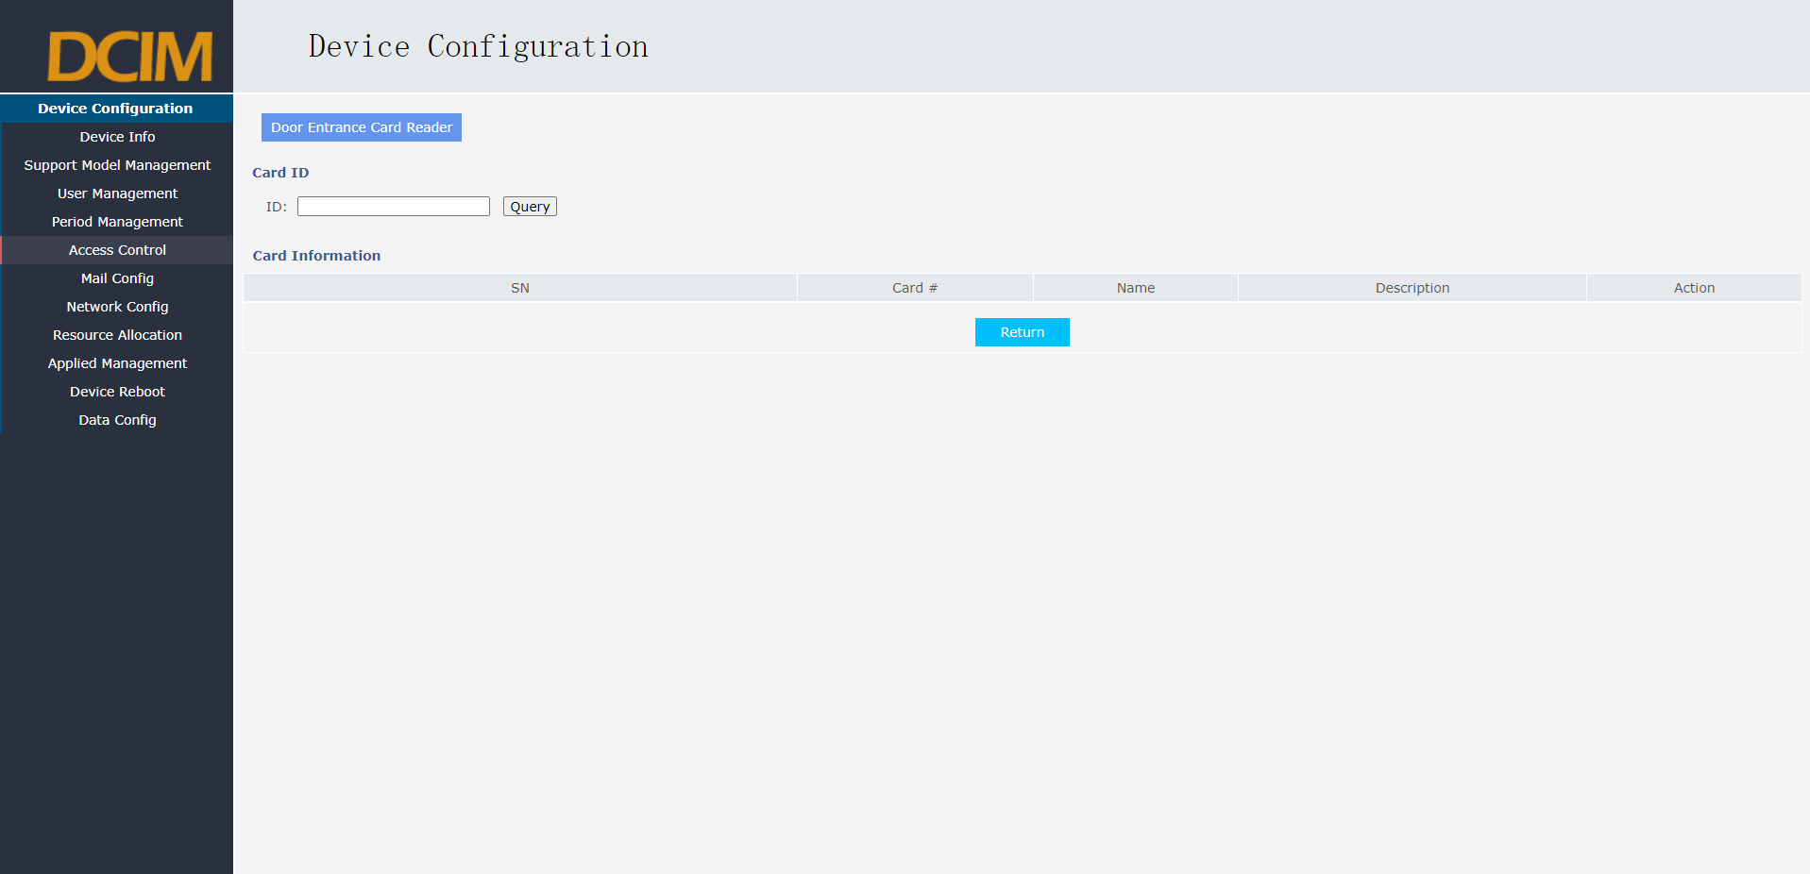

## Mailbox Configuration

1. The mailbox setting is the configuration of the mailbox sent by the mail alarm host
2. The page can set up the smtp server, mailbox account, mailbox password, smtp port, and message header

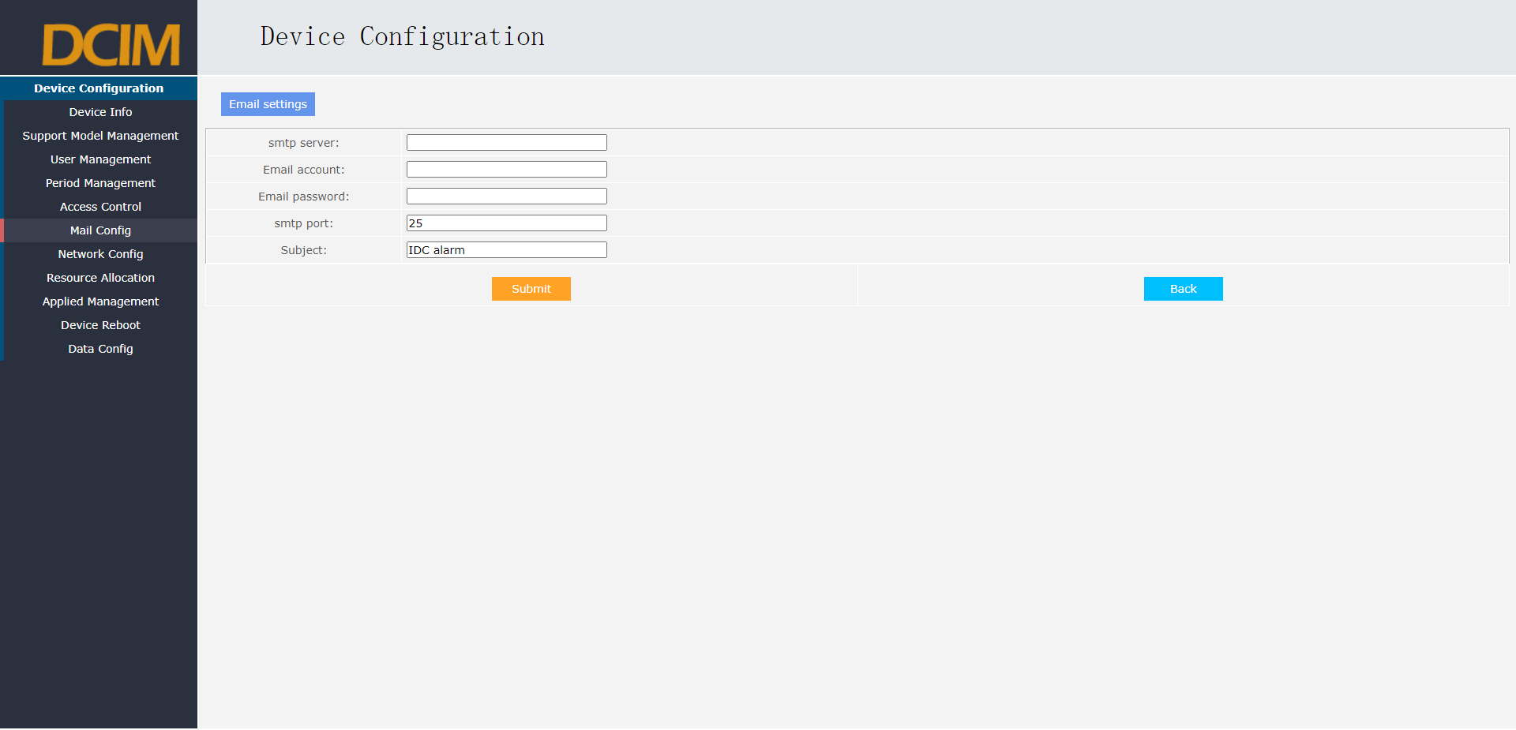

## Network Configuration

1. The monitoring host is redundant with dual-network port corresponding to IP address 1 and Ethernet2 network port corresponding to IP address 2, with 2 IP addresses for different network segment.
2. DHCP is turned off by default, and users can modify the cost-local LAN IP by setting the IP address, subnet mask, and gateway.
3. MAC Address The default physical address of the primary device.
4. DNS setting: Add DNS device to realize mail alarm and external access functions. Users should consider external access security issues when adding this setting, which is not set by default.

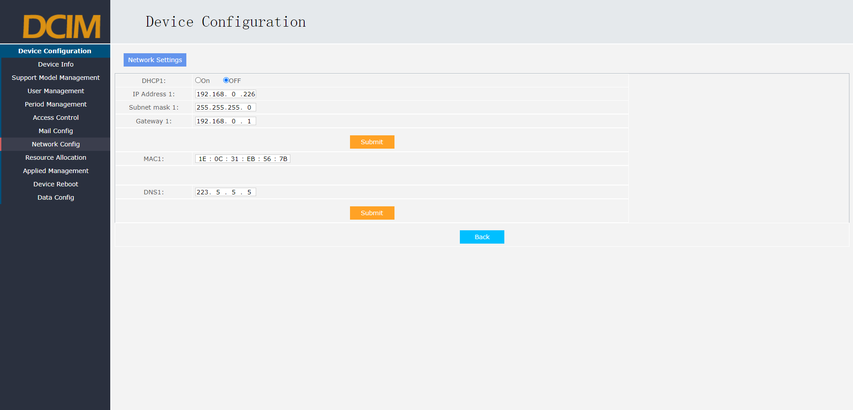

## Resource Allocation

1. Resource configuration is the reuse configuration of some hardware ports, including DO setting (switch output) and AI setting (analog input).
2. DO setting is to configure DO 1 ~ DO 8 enabled or disabled, the system default start state
3. AI setting: analog input split current 0 ~ 20 mA, voltage 0~3V, voltage 0~12V 3 different ranges, the default current 0 ~ 20 mA range.

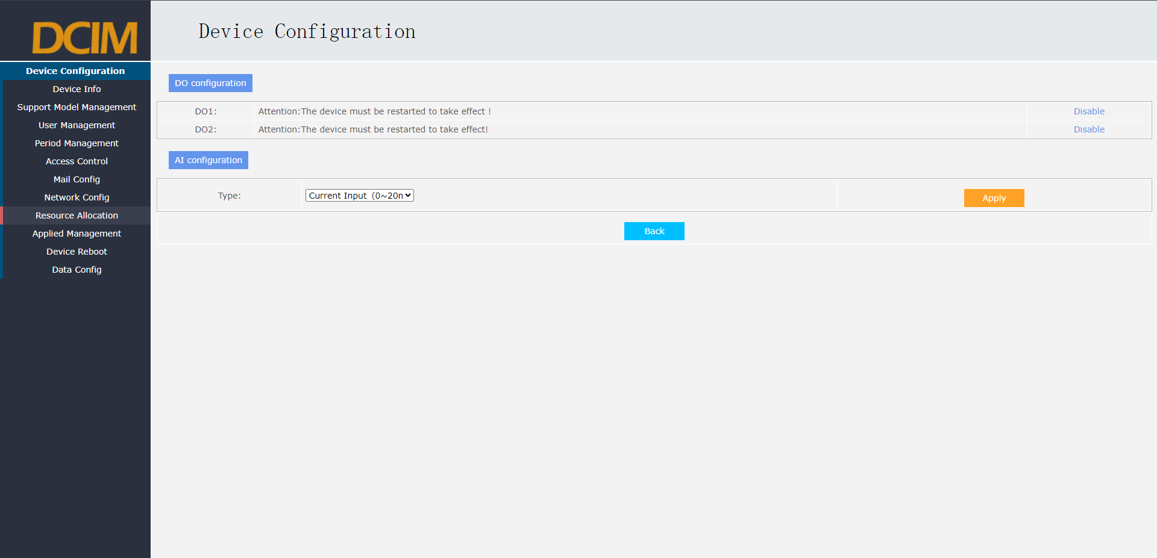

## Application Management

1. Application management is to open and stop the application software of the current system operation.
2. Start SU: open the monitoring system to run the application, generally after modifying or adding the monitoring equipment, it is necessary to start the SU application.
3. Stop SU: stop the monitoring system and running the application. Generally, the SU application needs to be stopped before modifying or adding the monitoring equipment.
4. Starting application and stopping application are mainly used to open or stop internal related debugging applications during system debugging. It can be opened or stopped by entering the application name in the window name. General users do not use this function.

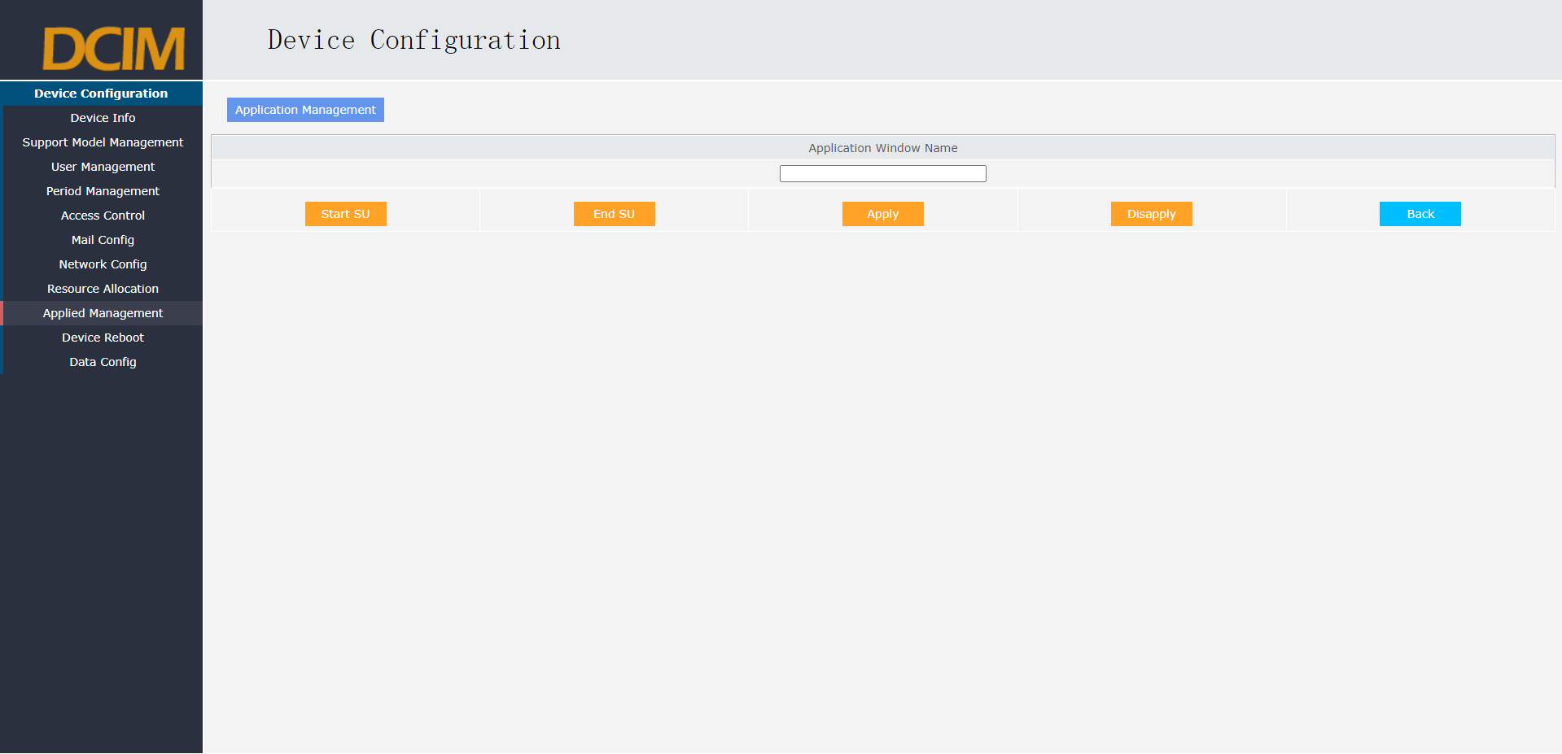

## Device Reboot

1. The restart device is a soft restart system function. Click the restart device to restart. Wait 1~2 minutes for the system to resume normal operation.
2. Add or modify the information for the monitoring device.

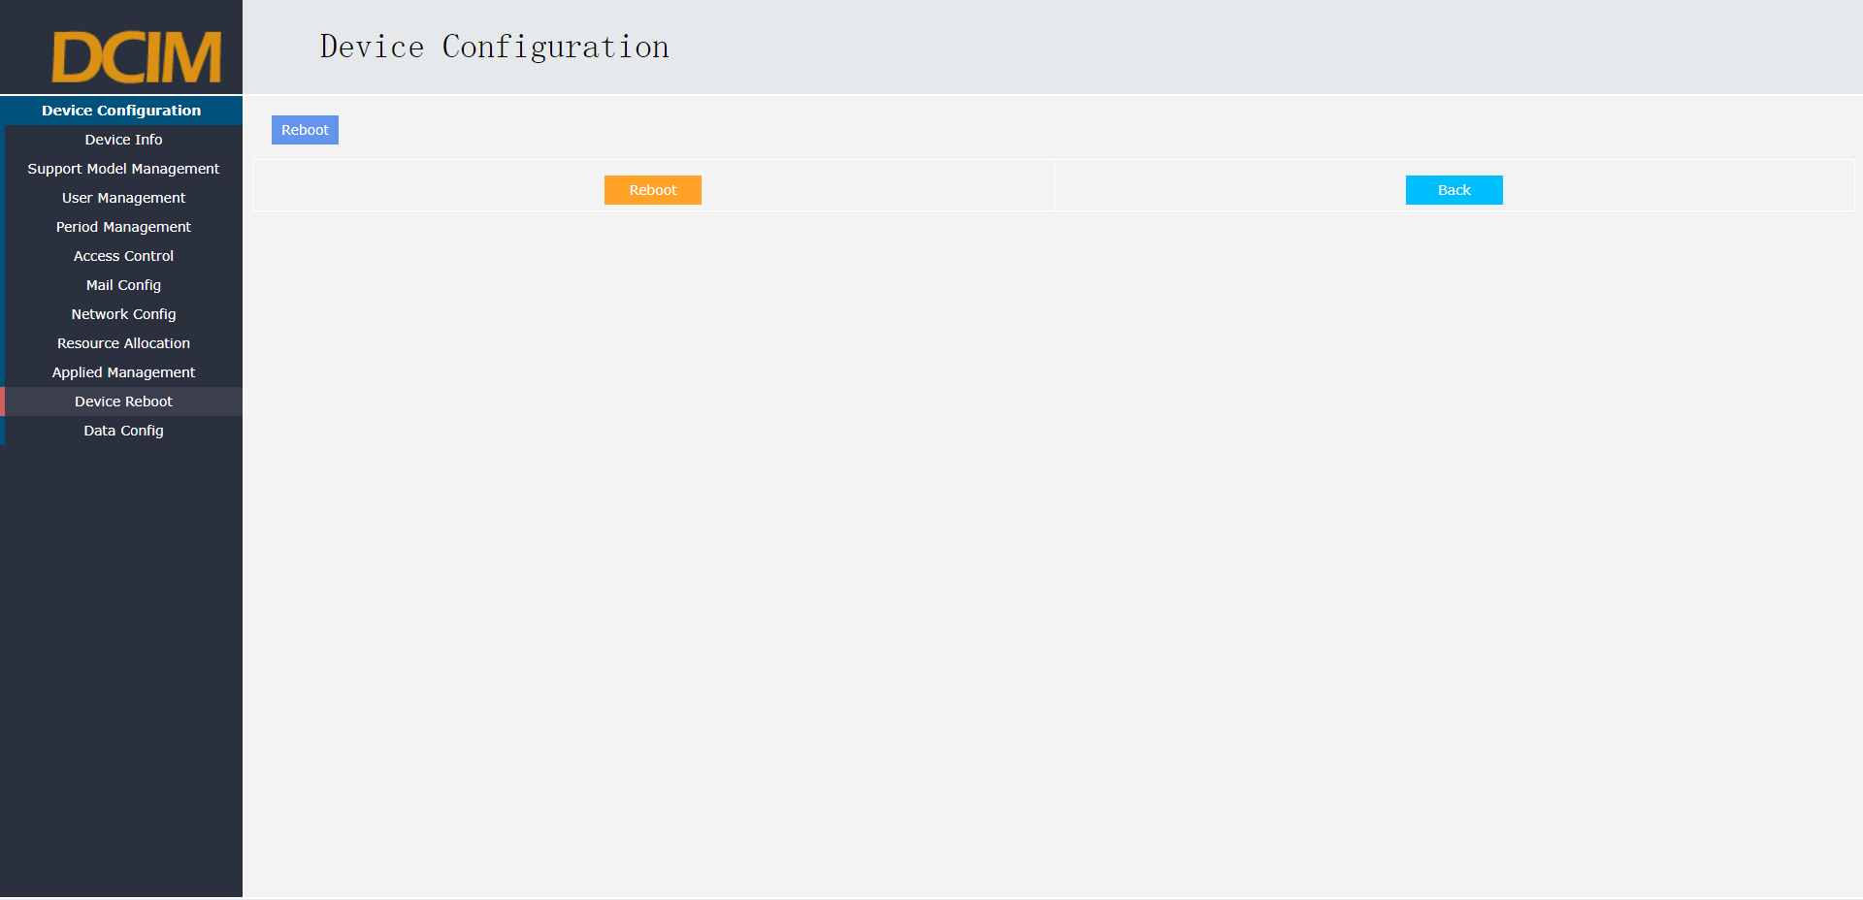

# Maintenance Overhaul

This chapter mainly explains the daily maintenance content of the monitoring system.

## Daily Inspection

[1] Check whether the monitoring host is running properly, and log in to the monitoring system to check.

[2] Check whether the network of the monitoring host is connected normally, and you can view the details of the host in the monitoring system.

[3] Check whether the monitored item has alarms.

[4] Check whether the system has detected water leakage, if there is any need to clean up the leakage as soon as possible.

[5] Check whether the temperature and humidity of each monitoring is normal, such as the temperature of the air room set 22, the general temperature shall not exceed 27℃,

The humidity shall not exceed 80%. In an environment with precision air conditioning, the temperature shall be within ± 5℃ of the set value, and the humidity shall be within ± 10% of the set value. Otherwise, please check whether the air conditioner is not working properly.

[6] Check whether there are strangers in each area during the time of fortification.

[7] Check whether the power supply of the screen cabinet is normal, and whether the dual power supply is working normally.

[8] Check the video entry of the personnel in each sub-machine room to see if there are any strangers entering the machine room.

[9] Check the event viewing records of the monitoring system, and there are no normal phenomena.

## Cyclic Check

* + 1. **Check every week**

1. Check and test the water leakage system for normal alarm every week.(It can simulate water pouring detection on the leakage rope, and the controller has no leakage
2. Water alarm, monitoring whether the host machine can accurately and timely alarm).
3. Test whether the sound and light alarm function works normally every week.
4. Check whether the operation of each monitoring item is normal every week.
   * 1. **Monthly inspection**
5. For the important equipment under the environment, the important parameters can check the historical curve, alarm, etc., to see whether it is within a reasonable range, and find whether there is any harm to the safe operation of the machine room.
6. Analyze the problems found by the monitoring system, analyze the frequency of failure, and propose some feasible solutions.
7. Check the setting parameters of each equipment, mainly the setting of air conditioning, to see whether the temperature and humidity are adjusted in time within a reasonable range
8. set value.
   * 1. **Monthly inspection**

[1] Check the performance of the host every June and monitor the server dust cleaning.

[2] Check whether the water leakage sensor rope contains dust every June, and clean it in time.

[3] Check and analyze the records of events and abnormalities, and the solutions, and propose further solutions.