

**[Please enter company name]**

**[Please enter company address]**

**[Please enter telephone number]**

**[Please enter fax number]**

**2024年9月26日**

Intelligent Data Center

ROC-A6 Monitoring Host User Manual

Version1.0

Copyright © Shenzhen Kuanpeng IoT Technology Co., Ltd.

# 

# Preface

Welcome to use our technology products.

This manual is prohibited from copying, quoting, or printing without permission. Changes may occur without prior notice with product updates.

Before use, please carefully read the user manual. We believe it will greatly assist you in effectively using this instrument.

Due to time constraints, this manual may have shortcomings. If you have any questions, please feel free to contact us. Thank you.

**Disclaimer**

The manual involves sensitive data such as system usernames, addresses, and organization names. Please ensure proper custody and do not provide it to unauthorized personnel. We do not assume any responsibility for data leakage caused by improper handling of the above.

Software malfunctions, hardware damage, network anomalies, etc., resulting from operations not following this manual are not within the scope of our service.

If you continue reading the contents of this manual, it is considered that you have read and agreed to the above statement.

# User Manual Introduction

This manual provides an overview of the hardware characteristics, installation methods, and precautions during the installation process of the ROC-A6 monitoring host.

The manual includes the following chapters:

Chapter 1: Product Introduction. Provides a brief overview of the basic functional features of the monitoring host and details its appearance.

Chapter 2: Product Installation. Guides the hardware installation methods of the monitoring host and provides related precautions.

Chapter 3: Hardware Connection. Guides the connection between the monitoring host and other devices, along with related precautions.

Chapter 4: System Login. Briefly describes the steps for logging into the monitoring host system.

Appendix A: Common Troubleshooting.

Appendix B: Technical Specifications.

Note: Before installing the device and during the installation process, to prevent potential equipment damage and personal injury, please carefully read the relevant content in this manual.

# Product Introduction

## 1.1 ROC-A6 Host Product Overview

ROC-A6 is a high-performance computer room power environment monitoring host. The system is based on the Freescale industrial ARM Cortex™-A7 embedded chip with high performance and low power consumption. It is equipped with Linux operating system, provides large capacity memory, and provides convenient embedded WEB services. Without relying on the upper computer software, it can complete the centralized monitoring and alarm functions of power supply and distribution, UPS, air conditioning, water leakage, temperature and humidity, infrared, access control, video images, etc. The monitoring host provides working power for various sensors. Can directly log in to the monitoring system through the browser, the system to establish a complete TCP/IP function, support ModbusTCP, JSON and other open interface protocols, can achieve flexible networking or cross-platform seamless integration.

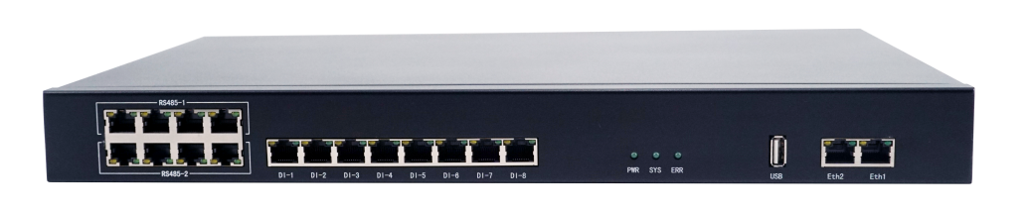

Figure 1-1 Appearance of the ROC-A6 host

## 1.2 Product Features

**Centralized Monitoring and Management**

The system provides comprehensive monitoring of various power equipment, environmental devices, and system status information, along with alarm data, within a single data center. It boasts excellent scalability, allowing for centralized monitoring and management across different regions.

**Auto-Start on Power Recovery**

The monitoring host utilizes a low-power ARM chip and an embedded operating system, with a built-in hardware watchdog. It has automatic fault recovery capabilities, and when the host restarts, the entire monitoring system resumes operation.

**WEB Display Function**

The monitoring host has a built-in WEB server, supporting B/S architecture. Authorized personnel can directly view the real-time operating status of all power and environmental monitoring devices in the equipment room through a browser. It enables remote management and adjustment of relevant equipment parameters.

**Comprehensive Alarm Mechanism**

The monitoring host supports multiple alarm methods, including on-site audio-visual alarms, telephone dialing alarms, mobile SMS alarms, email alarms, etc.

**User Permission Function**

The system features multi-level user management with configurable user permissions. Ordinary users can only browse the system, while administrators, in addition to browsing rights, can configure and manage the entire system.

**Arm/Disarm Function**

The environmental monitoring system is designed with user-friendliness in mind, allowing the setup of arm/disarm functions. Temporary disarmament times can be set to limit device alarms, facilitating flexible management of temporary work arrangements.

**Network Monitoring Function**

In addition to monitoring data center environmental parameters, the data center environmental monitoring system can also monitor IP devices such as routers and servers. It offers two monitoring methods: TCP port detection and PING detection.

## 1.3 Exterior Hardware interface description

**1.3.1 Ports on the front panel of the ROC-A6 Host**

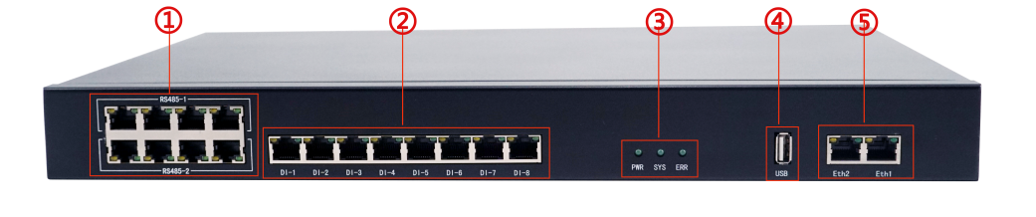

Figure 1-2 Front panel of the host

1. RS485 port
4. USB port

DI switch input port
5. Ethernet Ethernet port

3. Status indicator

**Note: Front panel indicator description:**

**1. Power status indicator**: Displays the power supply status. Long on indicates power supply.

**System status indicator**: Displays the operating status of the system. Blinking indicates that the system is working normally.

**3. Fault status indicator**: displays the fault status of the host, and if it is steady on, it indicates fault.

**1.3.2 ROC-A6 host rear board port**

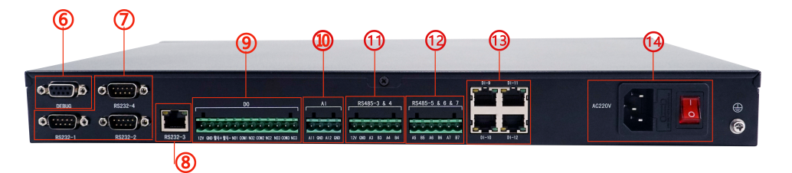

Figure 1-3 Rear panel of the host

1. Debug interface
2. RS232 interface (DB9 interface)
3. RS232 interface (RJ45 interface)
4. DO port, 1 wet contact, 3 dry contact
5. AI interface
6. RS485-3&4 interface
7. RS485-5&6&7 interface
8. DI port
9. Power supply port AC220V

# Product Installation

## 2.1 Item List

**Table 2-1** List of items

|  |  |
| --- | --- |
| **Name** | **Quantity** |
| ROC-A6 Monitor host | 1 |
| Power cord | 1 |
| Warranty Card | 1 |
| Accessories | 1 |

## 2.2 Installation precautions

* Keep the power off during the installation to avoid potential safety hazards;
* The monitoring host can only work normally under the correct power supply, please make sure that the power supply voltage is consistent with the voltage indicated by the host;
* Before powering on the monitoring host, make sure it won't overload the power circuit to prevent interference with the normal operation of the monitoring host or unnecessary damage.
* In order to avoid the danger of being clicked, do not open the shell when the monitoring host is working, even if it is not charged, do not open it by yourself;
* Before cleaning the monitoring host, the power plug of the monitoring host should be pulled out first, do not wipe with wet fabric, do not clean with liquid.
* **Installation environment precautions**

**Temperature/humidity**

To ensure long-term stable operation of the monitoring host and extend its service life, keep the environment at a certain temperature and humidity. Table 2-1 lists the normal operating temperature and humidity of the host.

**Table 2-1** Normal operating temperature and humidity of the host

|  |  |  |
| --- | --- | --- |
| Environment description | Temperature | Humidity |
| Working environment | - 20 ~ 70 ℃ | 10% to 95% (no condensation) |

**Indoor dust protection**

Dust on the surface of the monitoring host causes electrostatic adsorption, which prevents metal nodes from contacting properly. Pay attention to the following:

* Dust regularly to keep the indoor air clean;
* Ensure that the equipment is well grounded to ensure the smooth transfer of static electricity.

**Electromagnetic Interference**

Electromagnetic interference will affect the capacitive coupling, inductive coupling, impedance coupling and other conduction methods on the capacitance, inductance and other electronic components inside the equipment, in order to reduce the adverse impact of electromagnetic interference factors, please pay attention to the following:

* The power supply system shall take necessary anti-interference measures against the power grid;
* Monitoring host should be far away from high-frequency high-power, high-current equipment, such as wireless transmitter;
* Electromagnetic shielding measures should be taken if necessary.

**Lightning protection requirements**

During a lightning strike, a powerful current is generated instantaneously, which can cause fatal damage to electronic devices. To achieve better lightning protection, consider the following:

* Ensure that the grounding terminals of the rack and device are in good contact with the ground.
* Verify that power outlets are in good contact with the ground;
* Reasonable wiring to avoid internal induction thunder;
* When wiring outdoors, it is recommended to use a signal lightning arrester.

**Installation Table**

Whether the monitoring host is installed in the rack or other horizontal workbench, please note the following:

* Confirm that the rack or workstation is stable and sturdy, capable of withstanding at least 2.5kg of weight.;
* Ensure the rack itself has an effective cooling system or maintain good indoor ventilation.
* Confirm that the rack is well grounded.

## 2.3 Prepare the installation tools

* Phillips Screwdriver
* Antistatic wrist
* Network cable

## 2.4 Product Installation

* **Mount on a 19-inch standard rack**

The monitoring host can be easily installed on a 19-inch standard rack. The installation steps are as follows:

1. Check the grounding and stability of the rack;
2. The monitoring host is placed in the appropriate position in the frame, supported by the bracket;
3. Screw the L-shaped bracket on the guide slots fixed at both ends of the frame to ensure that the host is mounted on the frame stably and horizontally. See Figure 2-1.

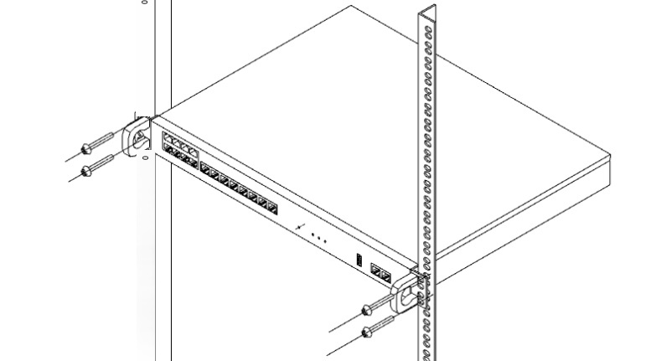

Figure 2-1 Rack installation diagram

# Hardware connection

## 3.1 Cable Connection

Connect the Ethernet 1 or Ethernet 2 port of the monitoring host to a PC using an Ethernet cable. Log in to the system, modify the IP to the local LAN IP, and then connect it to the local LAN to complete the hardware connection. All PCs in the LAN can manage the monitoring system through a web browser.

* **Connect to the PC and change the IP address of host**

Use a network cable to connect the PC to the Ethernet port on the monitoring host, and log in to the system to change the IP address of the monitoring host, as shown in Figure 3-1.

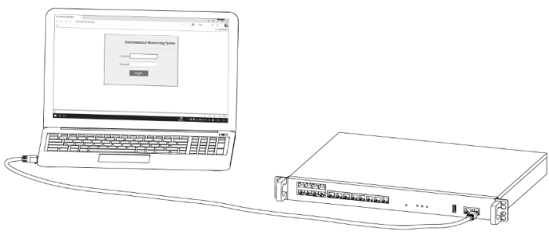

Figure 3-1 The PC is directly connected to the monitoring host

* **Connecting to the Local Area Network LAN**

Use an network cable to connect the Ethernet port on the monitoring host to the hub or switch on the LAN, as shown in Figure 3-2.

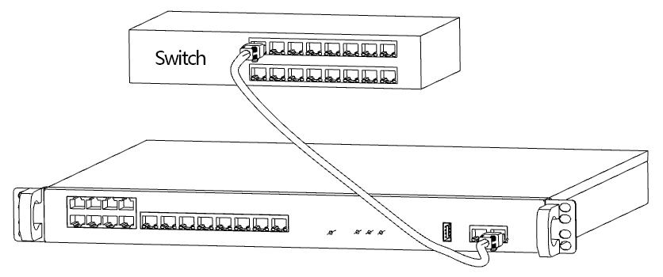

Figure 3-2 Monitoring host access switch

**Note:**

* **After powering on, check the status of the port indicator lights. If the Link/Act light is on, it indicates that the link is normal. If the Link/Act light is off, check the link.**
* **Please use a Category 5e twisted pair cable for the connection.**
* **The default IP address of the monitoring host is 192.168.0.xx. The factory-set IP address is posted near the port.**

## 3.2 Power Cable Connection

**The monitoring host uses AC220V AC power supply.**

1. Check that the selected power supply is consistent with the power supply requirements marked on the host;
2. Connect the original power cable of the host to the power socket, as shown in Figure 3-3.

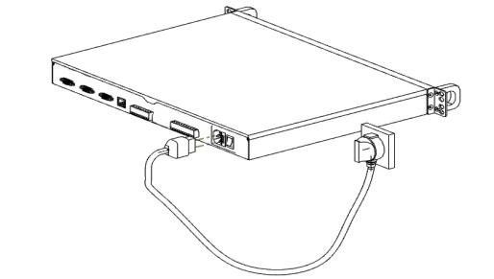

Figure 3-3 Connecting the power cable

**Note: The power supply of the power supply system must be in good contact with the ground. Check the position of the power switch on the device so that the power supply can be switched off in case of an accident.**

## 3.3 Device initialization

After connecting the power, the monitoring host will automatically initialize, and the following conditions will appear in the indicator light:

* Pow indicator light constantly on indicates correct power connection, and off indicates power supply abnormality:
* After 30 seconds, the System indicator light will start blinking, indicating the completion of initialization.
* Err indicator light constantly on indicates device abnormality.

## 3.4 Post-Installation Check

Check the following after installation:

* Check whether there is enough heat dissipation space around the host and whether the air circulation is smooth;
* Check whether the power supply of the power socket meets the specifications of the host;
* Check that the power supply, host, rack and other equipment are properly grounded;
* Check that the host is properly connected to the switch.

# System Login

## 4.1 Setting Up Computer

1. The common PC is connected to port Ethernet1 on the monitoring host through network cable.

Set the local IP address of the PC to 192.168.0.x, x to an integer ranging from 2 to 254, the subnet mask to 255.255.255.0, and the default gateway to 192.168.0.1, as shown in Figure 4-1.

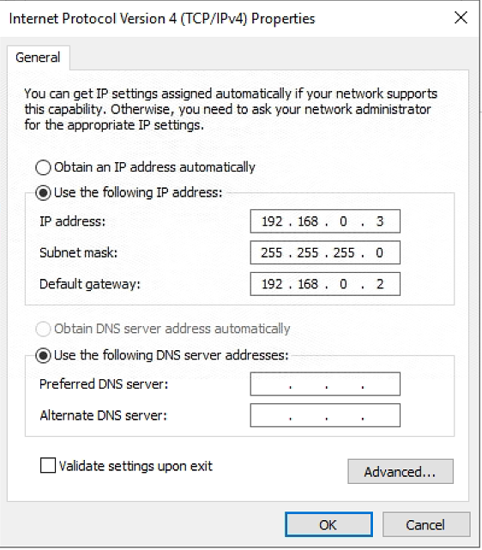

Figure 4-1 Local connection

**Note: The local IP address of the PC cannot be the same as that of the monitoring host to prevent IP conflict.**

## 4.2 Change the IP Address of the Monitoring Host

1. Open Internet Explorer, enter the host address http://192.168.0.xx in the address box, and press enter key. The host IP address is stuck near the port before delivery.

Log in to the system page

When logging in, the initial user name is **Admin**, with no default password . After confirmation, click "Login" to enter the system, as shown in Figure 4-2.

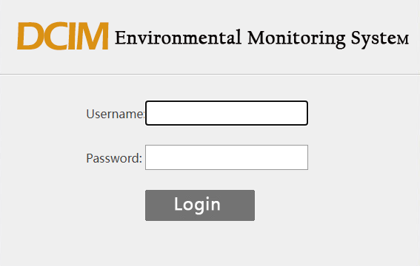

Figure 4-2 login page

3. Log in to the home page of the system, click "Device Configuration" under the left menu configuration option to enter the device configuration interface, click "Network Settings" on the left menu, change the current IP address, subnet mask, gateway in the local LAN environment IP address, subnet mask, gateway under the network Settings page, and click "Submit". Click "OK" in the pop-up dialog box to change the IP address successfully. The host supports 2 network ports, you can set it on demand, if you need to access through the Internet, set DNS. As shown in Figure 4-3 and 4-4.

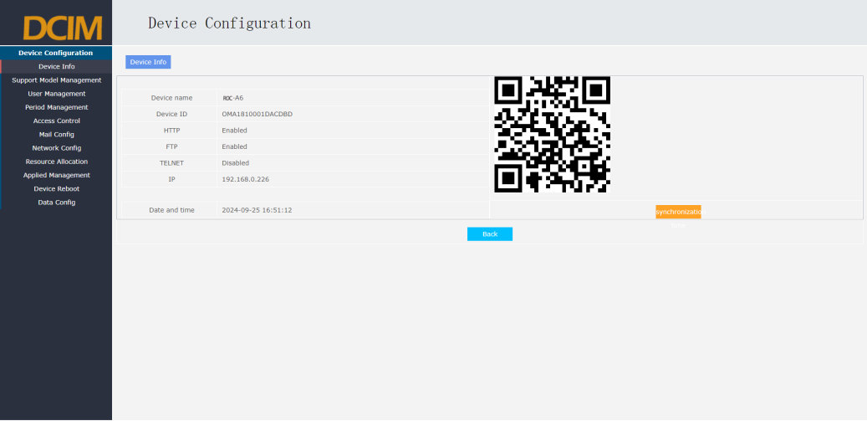

Figure 4-3 Device configuration page

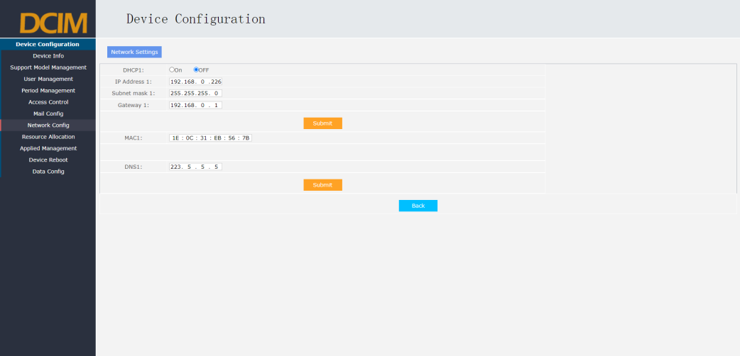

Figure 4-4 Network Settings page

4. Restart the device, click "Restart Device" in the left menu, click "Restart Device" in the page, and click "OK" in the pop-up dialog box. The host will restart immediately, and the modified IP address operation will take effect.

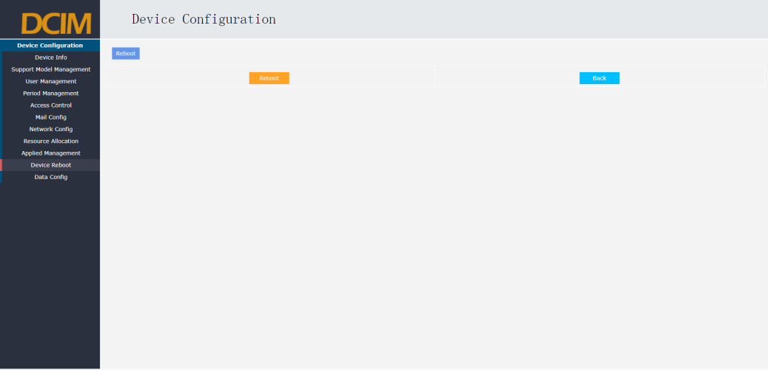

Figure 4-5 Restart Device Page

## 4.3 Re-login to the System

1. Connect the monitoring host to the LAN. Use a network cable to connect the Ethernet port of the monitoring host to the hub or switch in the LAN.

2. Open the Internet Explorer, enter the modified IP address of the monitoring host in the address box http://xx.xx.xx.xx, and press enter to log in to the system again. At this time, you can remotely manage the monitoring system on the local area network(LAN).

# Appendix A Common Troubleshooting

**Fault 1. The power indicator is abnormal.**

When the power system is working normally, the power indicator should remain on. If the power indicator is not on, please check it:

1. Monitor whether the power cable of the host is correctly connected, and ensure that the power cable plug is fully inserted into the power socket of the host;

2. Whether the power supply matches the power supply required by the monitoring host.

**Fault 2. Unable to Log into the System**

Please check using the following methods:

1. Check whether the system indicator is blinking, whether the Ethernet port cable is properly connected, and whether the network cable is damaged.

2. If you access the management monitoring system through the local computer, ensure that the IP address of the local computer and the IP parameters of the monitoring host are in the same network;

3. Run the Ping command to check the network connection and ensure that the IP addresses of the monitoring host do not conflict with those of other network devices.

4. If you have changed the IP address of the monitoring host, check whether the IP address for logging in to the system is the same as the new one.

**Fault 3. Unable to Browse the System Interface**

1. If the display is abnormal, upgrade or use another browser.

2. If the pop-up window is prohibited, please lower the security Settings of the browser.

**Problem 4. Forget the user name and password of the monitoring host**

Please contact the after-sales service personnel to remotely restore factory Settings.

# Appendix B Technical specifications

|  |  |
| --- | --- |
| Specifications and Models | ROC-A6 |
| Intelligent Computer Room System | A6 v1.0 |
| System Architecture | Embedded Linux operating system, ARM Cortex™-A7 high-performance processor, B/S architecture |
| Network Port | 2 channels 10M/100M adaptive interface, physical port: RJ-45 port |
| RS485 serial port | 13 ports, 8: RJ-45 ports with 12V power supply, 5:5.08 industrial terminals. |
| RS232 serial port | 4 ports, 1: RJ-45 ports, with 12V power supply; 3 standard DB9 ports |
| DI input | 12 optical coupling isolation switch input (supports dry contact signal) port, physical port: RJ-45 port, with 12V power supply |
| DO output | 1 wet contact (12VDC) interface, 3 relay normally open normally closed output (dry contact) interface |
| AI Input | 2 analog input interfaces, support 0~20mA or 0~3V, 0~ 5V range is optional |
| USB port | 1 USB port |
| Indicator | 3 indicators, which are power supply indicator, system operation indicator, and system failure indicator |
| Output power supply | 1 12VDC/1A standard power output port |
| Power supply | AC 220V, maximum power consumption 50W, while optional built-in 72W/30min backup lithium battery power supply, can work for about 24 hours in power failure delay |
| Physical size | 430mm*300mm*44.5mm (standard 1U) |
| Working environment | Temperature: -25 to 70 ° C; Humidity: 10% to 95% (no condensation) |
| Weight | 2.0 Kg |