1.定时简报（平安短信）Scheduled Briefing

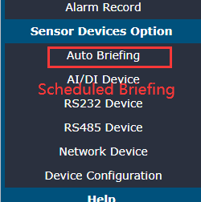

2.Switch quantity 开关量

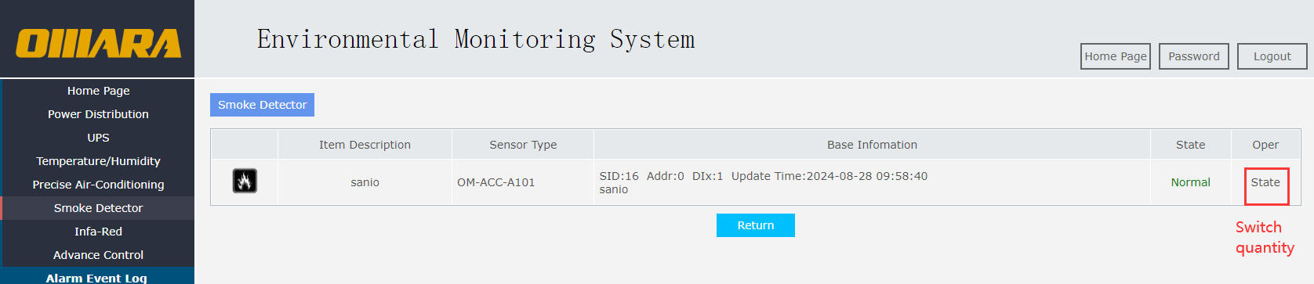

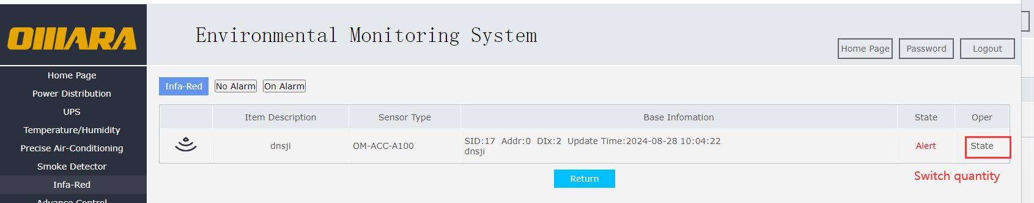

1. 撤防/布防 Disarm/Arm

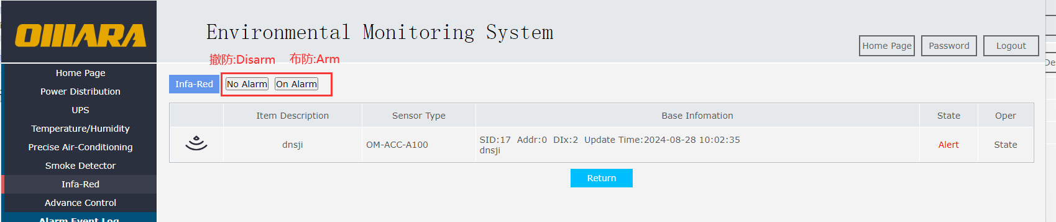

4.数据配置Data Configuration

