注意: 9月18号前发货出来，发顺丰！谢谢！

漏水绳采购明细如下：

|  |  |  |  |  |  |  |  |  |  |  |  |  |  |  |  |  |  |
| --- | --- | --- | --- | --- | --- | --- | --- | --- | --- | --- | --- | --- | --- | --- | --- | --- | --- |
|  | **序** | | | |  | **设备名称** | | **品牌** | | **型号** | | **单** | | **数量** | | **备注** |  |
|  | **号** | | | |  | **位** | |  |
|  |  |  | |  | |  | |  | |  |  |
|  |  | |  | |  |  | |  | |  | |  | |  | |  |  |
|  | **一** | |  | |  | **定位漏水报警器** | |  | |  | |  | |  | |  |  |
|  |  | |  | |  |  | |  | |  | |  | |  | |  |  |
| 1 | | |  | |  | 定位漏水监测器 | | OMARA | | OM-LDA-A801 | | 台 | | 15 | |  |  |
|  |  | |  | |  |  | |  | |  | |  | |  | |  |  |
| 2 | | |  | |  | 定位漏水检测电缆-5M | | OMARA | | OM-LDA-A601/5 | | 根 | | 3 | | 1、定位式漏水检测绳，长度 5 米； 2、线缆直径：6.0mm。 |  |
| 3 | | |  | |  | 定位漏水检测电缆-10M | | OMARA | | OM-LDA-A601/10 | | 根 | | 10 | | 1、定位式漏水检测绳，长度 10 米； 2、线缆直径：6.0mm。 |  |
| 4 | | |  | |  | 定位漏水检测电缆-15M | | OMARA | | OM-LDA-A601/15 | | 根 | | 10 | | 1、定位式漏水检测绳，长度 15米； 2、线缆直径：6.0mm。 |  |
| 5 | | |  | |  | 定位引出端 | | OMARA | |  | | 个 | | 15 | | |  | | --- | |  | |  |
|  |  | |  | |  |  | |  | |  | |  | |  | |  |  |
| 6 | | |  | |  | 定位终止端 | | OMARA | |  | | 个 | |  | |  |  |
|  | |  |  | | 15 | |  |  |
|  | | |  | |  |  | |  | |  | |  | |  | |  |  |
| 7 | | |  | |  | 固定架贴 | | OMARA | |  | | 个 | | 250 | | 配套赠送 |  |
|  | | |  | |  |  | |  | |  | |  | |  | |  |  |
| 8 | | |  | |  | 标签 | | OMARA | |  | | 个 | | 250 | | 配套赠送 |  |
|  |  | | | |  |  | |  | |  | |  | |  | |  |  |
|  | **二** | |  | |  | **非定位漏水报警器** | |  | |  | |  | |  | |  |  |
|  |  | |  | |  |  | |  | |  | |  | |  | |  |  |
| 1 | | |  | |  | 非定位漏水监测器 | | OMARA | | OM-LDA-B801 | | 台 | | 3 | |  |  |
|  | | |  | |  |  | |  | |  | |  | |  | |  |  |
| 2 | | |  | |  | 非定位漏水检测电缆-3M | | OMARA | | OM-LDA-B601/3 | | 根 | | 3 | | 专业漏水检测绳，长度 3 米 |  |
| 3 | | |  | |  | 非定位引出端 | | OMARA | |  | | 个 | |  | | |  | | --- | |  | |  |
|  |  | |  | |  |  | |  | |  | |  | | 3 | |  |  |
| 4 | | |  | |  | 非定位终止端 | | OMARA | |  | | 个 | |  |  |
|  | |  |  | |  | |  |  |
|  | | |  | |  |  | |  | |  | |  | |  | |  |  |
| 5 | | |  | |  | 固定架贴 | | OMARA | |  | | 个 | | 50 | | 配套赠送 |  |
|  | | |  | |  |  | |  | |  | |  | |  | |  |  |
| 6 | | |  | |  | 标签 | | OMARA | |  | | 个 | | 50 | | 配套赠送 |  |
|  |  | |  | |  |  | |  | |  | |  | |  | |  |  |
| **三** | |  |  | **非定位漏水报警器（含断线检测功能）** | | |  | |  | |  | |  | |  | |
|  | |  |  |  | | |  | |  | |  | |  | |  | |
| 1 | | |  | |  | 非定位漏水控制器（含断线检测） | | OMARA | | OM-LDA-C801 | | 台 | | 2 | |  |
| 2 | | |  | |  | 非定位漏水检测电缆（含断线检测）-5M | | OMARA | | OM-LDA-C601/5 | | 根 | | 2 | | 专业漏水检测绳，4芯，长度 5 米 |
| 3 | | |  | |  | 非定位引出端（含断线检测） | | OMARA | |  | | 个 | | 2 | |  |
| 4 | | |  | |  | 非定位终止端（含断线检测） | | OMARA | |  | | 个 | | 2 | |  |
|  | | |  | |  |  | |  | |  | |  | |  | |  |

**注：**

**一、定位漏水控制器需带 NO、NC 输出（增加漏水绳断线时NO、NC 也会有报警动作）；485 接口，如下图**

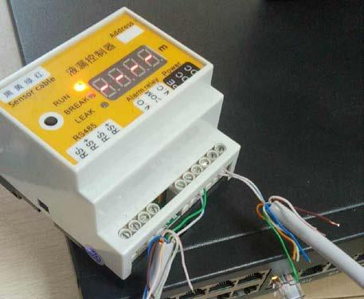

**二、非定位漏水控制器带 NO、NC 输出：485 接口，如下图**

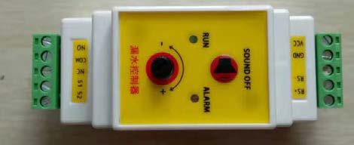

**二、定位漏水绳和非定位漏水绳均按照下图制作（图示为非定位漏水绳）。**

**1、** **漏水绳终止端样式**

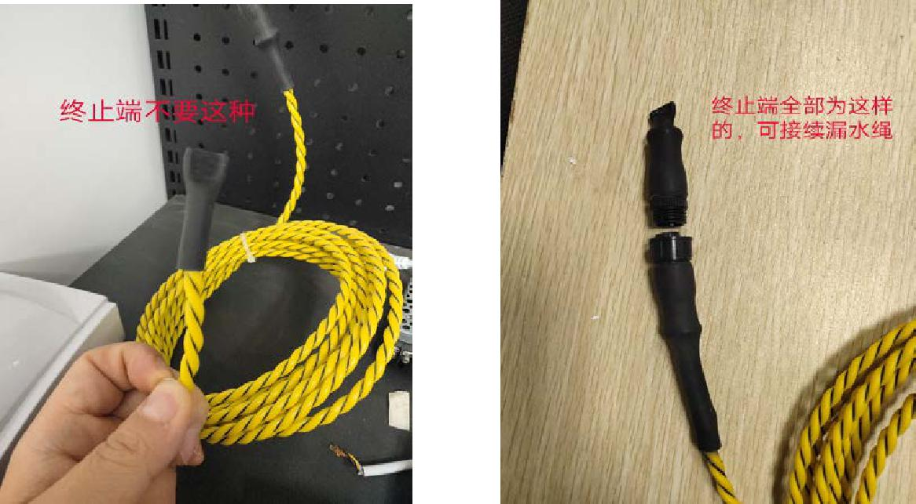

**2、** **漏水绳、漏水绳引出端、终止端、固定胶贴单独包装；固定胶贴一个大包装即可，**

**漏水绳单根一个单独装包装，**

**引出端、终止端按套单独一套一个包装。**

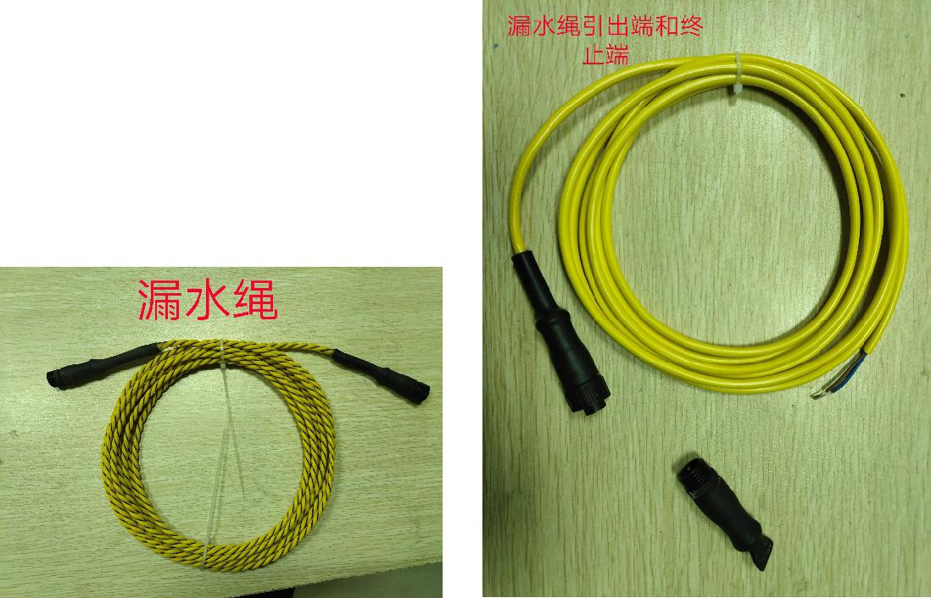

**全套使用方式如下**

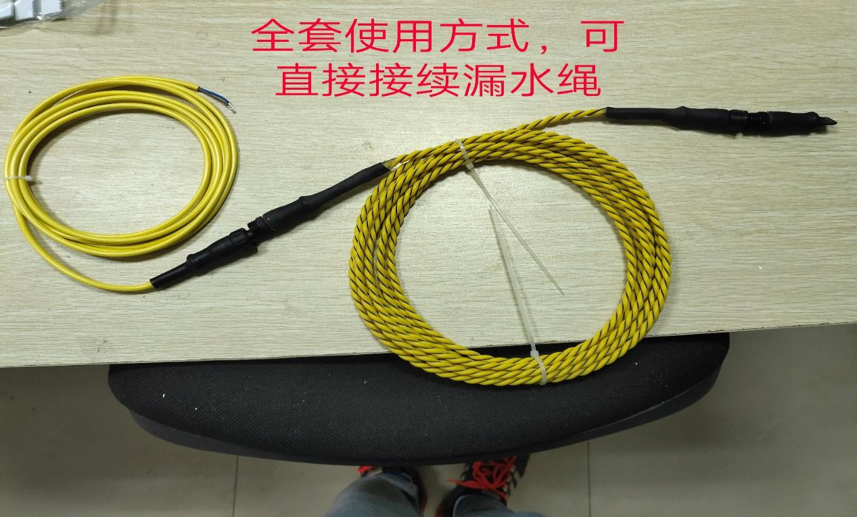

**3、** **品牌型号按照清单打即可**

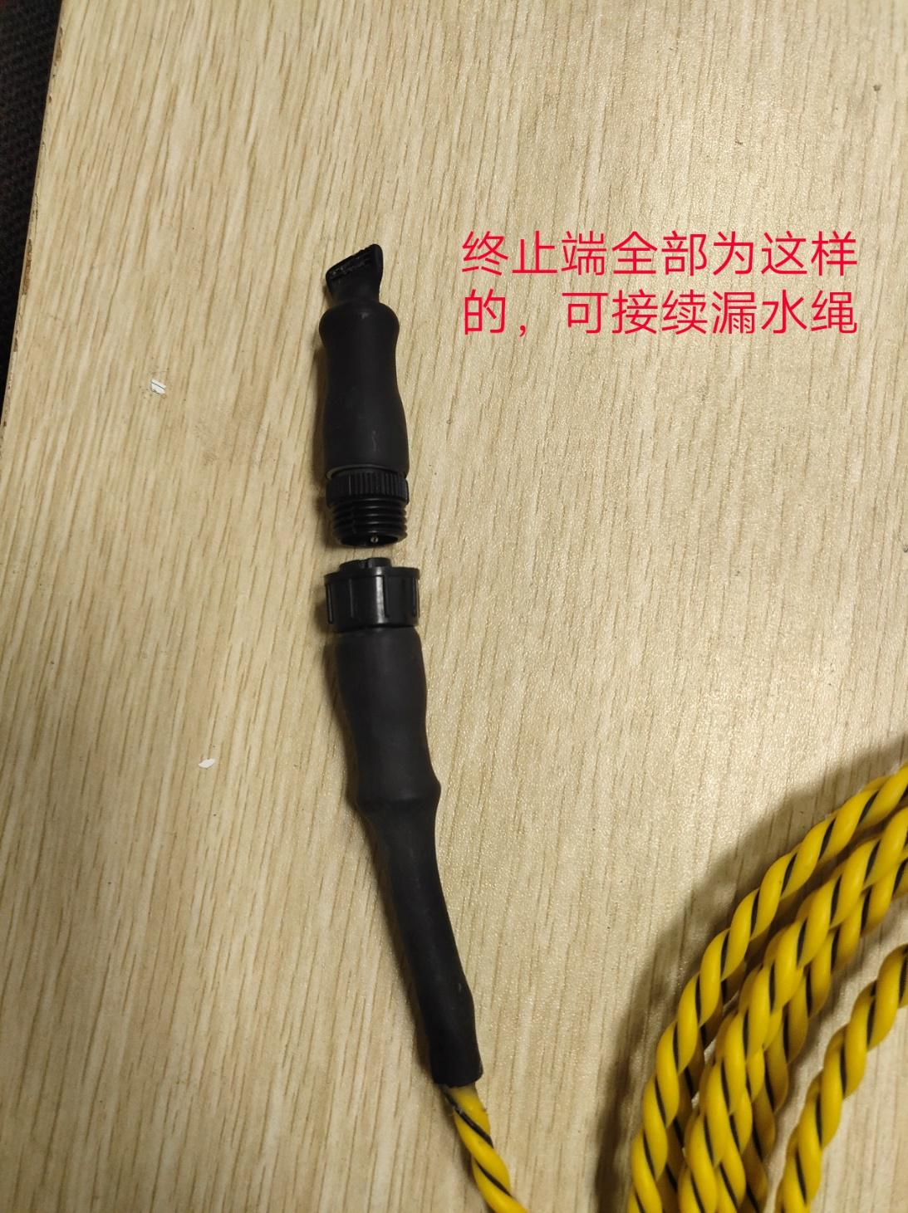

**4、** **定位式和非定位式漏水的连接端、终止端都采用小接头，如图所示：**

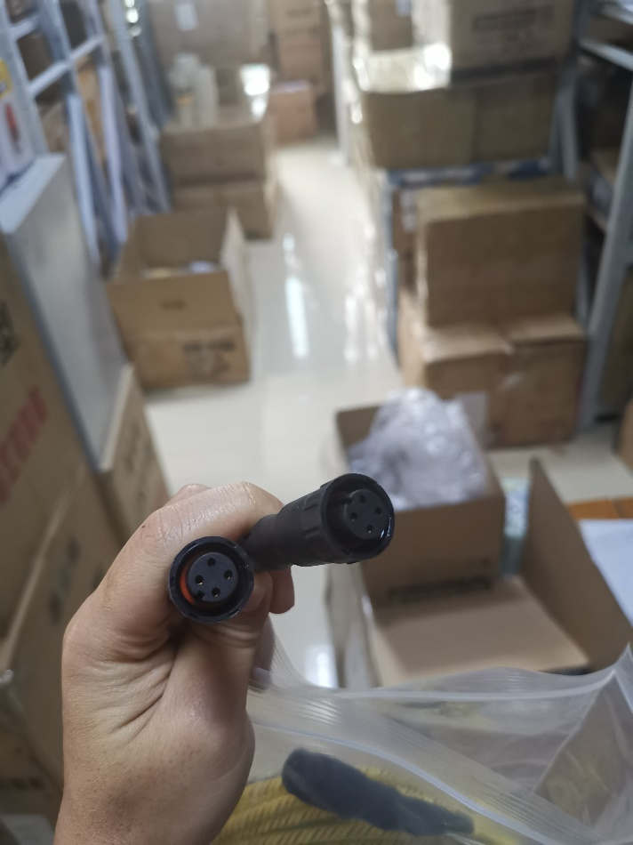**定位式**

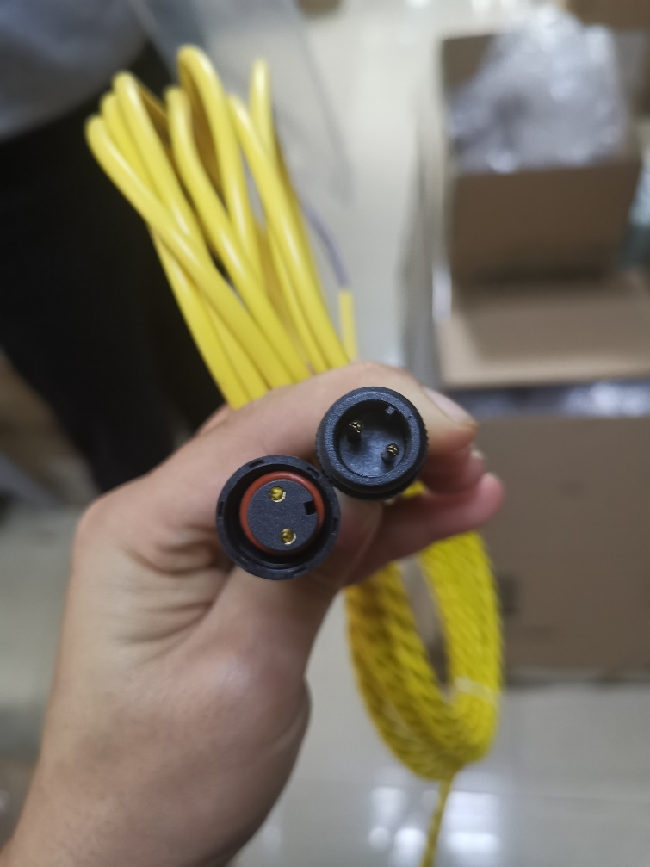**非定位式**