**开环霍尔电流传感器JCE500-EKS IP=500A**

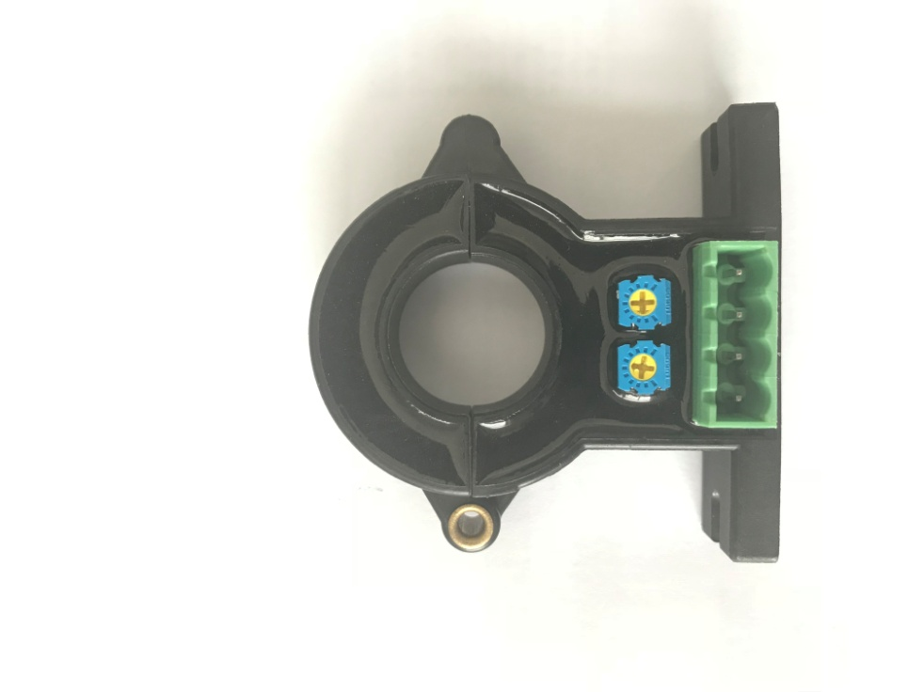



**注意Remarks**

**产品特点Products Features**

安装方便

Easy mounting

体积小，节省空间

Small size and space saving

无插入损耗

No insertion losses

抗干扰能力强

High immunity to external nterference

**应用领域Applications**

错误的接线可能导致传感器损坏。

The false wiring may result in the damage of the sensor.

Ip方向与产品箭头方向一致时，输出电压为正极。

VOUT is positive when IP flows in the direction of the arrow.

当初级导体完全充满初级孔径时动态表现（di/dt和响应时间）为最佳效果。

Dynamic performances (di/dt and response time) are best with a single bar completely filling the primary hole.

初级导体的温度不应超过100℃。

Temperature of the primary conductor should not exceed 100°C.

这是一个标准的产品，需要其他规格（测量电流、电源电压、输出电压、连接器、转换比率等）请联系我们。

This is a standard model. For different versions (IP,supply voltages, output voltages,connection of secondary,turns ratios...),please contact us.

交流变速驱动器

AC variable speed drives

直流电机驱动静态转换器

Static converters for DC motor drives

通讯电源

Battery supplied applications

不间断电源 (UPS)

Uninterruptible Power Supplies

开关电源 (SMPS)

SWITCHED Mode Power Supplies

电焊机

Power supplies for welding applications

**机械尺寸Mechanical dimension**



**①**

**① 第一供应商7.5mm，第二供应商6mm，默认二者按批次随机发货，如有特殊要求请备注。**

**机械特性Mechanical characteristics**

一般公差

General tolerance ± 0.5 mm

其它公差执行

Other tolerance execution GB/T 1804-2000-M

固定孔尺寸

Fixing hole size Φ4.5mm

紧固螺丝

fastening steel screw M4

建议紧固扭矩

Recommended fastening torque 0.75Nm (± 10 %)

连接器

Connection of secondary KF2EDGCV-X5.08-4P

连接器推荐扭矩

Connector recommended torque 0.3Nm (± 10 %)

**电气参数Electrical data JCE500-EKS**

除非另有说明，否则环境参数均为@ *T*A = 25 °C, *R*L = 10 kΩ

|  |  |
| --- | --- |
| 型号  Type | JCE500-EKS |
| 额定测量电流IP  Rated input | ±500A |
| 测量范围 IPM  Measure range | ±1000A |
| 额定输出电压 VOUT  Rated output voltage | ±4V |
| 零点失调电压VO  Offset voltage | ±20mV |
| 电源电压VC  Supply voltage | ±12VDC～±15VDC（± 5%） |
| 绝缘耐压 VD  Galvanic isolation | 50Hz，1min，3KV |
| 负载电阻 RM  Load resistance | ≥10KΩ |
| 线性度 εL  Linearity | ≤1%FS |
| 总体精度 X  Overall accuraty | ±1% |
| 零点失调电压温漂VOUT  Offset voltage drift | ±0.5mV/℃ |
| 幅度电压温度漂移VOUT  Amplitude voltage temperature drift | ≤0.1%/℃ |
| 静态电流消耗IC  Current consumption | ≤15mA |
| 响应时间TR  Response time | <7μs |
| 频带宽度BW  Frequency bandwidth-3db | DC～25KHz |
| di/dt跟随精度  di/dt accurately followed | >50A/μS |
| 工作环境温度TA  Ambient operating temperature | -40～+85℃ |
| 储存环境温度TS  Ambient storage temperature | -40～+125℃ |
| 质量 m  Mass | ≈65g |
| 执行标准  Standards | SJ 20790-2000；JB/T 7490-2007 |