不带计量的485智能断路器通讯协议
版本 | 作者 | 备注
V1.0 | 谈炳荣
V1.1 | 谈炳荣

Background:
背景：
This document mainly describes the protocol between the following devices:
本文档主要描述以下几个设备之间的通讯协议：
- The protocol between the internal communication module of the intelligent circuit breaker and the various RS485 circuit breakers. The communication interface uses RS 485, the communication configuration is 2400Bps, 1 initializing bit, 8 data bits, no parity bit and 1 stop bit.
- 智能断路器内部的通讯模组和各个RS485断路器之间的通讯协议。通讯接口采用RS485，通讯配置为波特率 2400,1位起始位，8位数据位，无校验位，1位停止位。

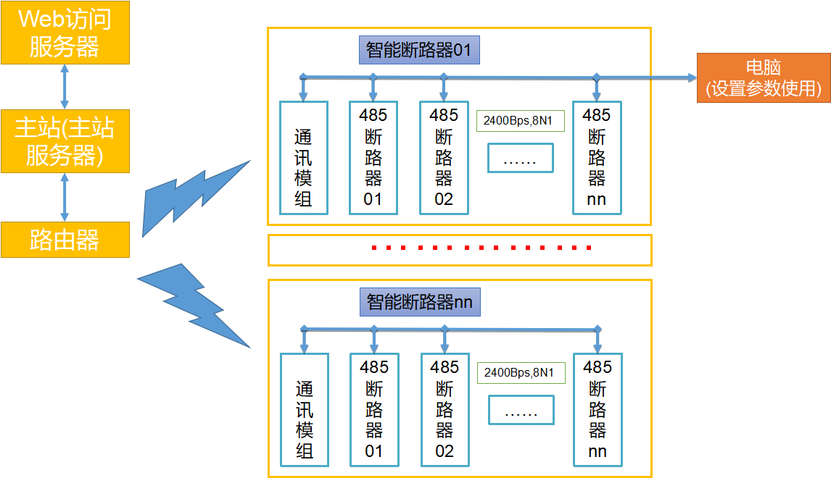

Communcation protocol standard
通讯协议的规约格式
说明 Description | 代码 Code
帧起始符 Frame starter | 0X68
地址域（0X00~0XFD,0XFF为广播地址）  Address field  (0X00~0XFD,0XFF is the broadcasting address) | A0
控制码 control code | C
数据长度（0x0~0xc8）  Data length (0x0~0xc8) | L
数据域 Data field | DATA
校验码（1字节）Check code (1 byte)  从帧起始符开始到校验码之前的所有字节的数据和，超过0xFF取低8位（1字节）  The total of all bytes from the initial frame up to the check code, limit to 8 bits if exceeds 0xFF (1 byte) | CS

Frame starter (1 byte): The start of the frame, specified as hexadecicmal at 0x68
帧起始符(1字节)：帧起始标识，指定为H或十六进制0x68；
Address (1 byte) : address (0X00~0XFD,0XFF is the broadcasting address)
地址 (1字节)：地址（00H~FDH，FF为广播地址）；
Control code (1 byte): used to specify the type of frame. See the following table for specific definitions.
控制码 (1字节)：识别该帧类型，具体定义见下表。
Data length (1 byte): the number of bytes of the data content.
数据长度(1字节)：数据内容的字节个数。
Data content (0-n bytes): actual communication content. Differs by use case.
数据内容 (0-n字节)：实际通信内容。根据不同业务分别说明；
Check (1 byte): The data total of all frame content( including the frame starter, address, data length etc.)(All bytes from the start of the frame up to the check code). Truncate to lowest 8 bits (1 byte)
校验 (1字节)：帧内容（包括帧起始符、地址、数据长度、控制码、数据内容等）(从帧头开始到校验之前的所有字节)的数据和，超过0xFF取低8位（1字节）
举例：
For example：
68 01 01 01 10 CS
CS=(68H+01H+01H+01H+10H)%100H=7BH

68 D0 01 01 10 CS
CS=(68H+D0H+01H+01H+10H)%100H=4AH

Control code definition
控制码定义：
应答标志  Response flag(bit7) | 帧错误  Frame error (bit6) | 有效控制码  Effective control code (bit0-bit5)
0 -- 发起 initialize  1 -- 应答 response | 0 -- 正确 correct  1 -- 错误 incorrect | 00-3FH,有效的控制码  00-3FH, Effective control code  0X7FH---- Setting the address and model of the circuit breaker(Using broadcast address setting)

Common control codes
通用的控制码列表：
序号  Serial Number | 控制码  Control  Code | 对应操作  Corresponding action | 适用范围  Application scenarios | 适用通讯地址  Applicable communication address
1 | 0x01 | 读RS485断路器  Read from RS485 circuit breaker |  | 0X00~0XFD
2 | 0x02 | 写RS485断路器  Write to RS485 circuit breaker |  | 0X00~0XFD,  0XFF(广播)  0XFF(broadcast)
3 | 0x7F | 设置断路器地址及型号  Set the circuit breaker address and model | 断路器设置按键拨到设置时有效  Used when the red toggle switch is set to settings. | 0XFF(广播)  0XFF(broadcast)

Specifications
规约说明
- Setting the address and model of the circuit breaker
- 设置断路器的地址及型号
Using broadcast address setting, the red toggle switch must be set to setting position in order to setup the switch.
采用广播地址设置，设置时将要设置的断路器的红色拨动开关拨到设置位置。
The command frame is as follows:
命令帧如下：
帧头(1)  Frame starter(1) | 地址(1)  Address(1) | 控制码(1)  Control code (1) | 数据长度(3)  Data length  (3 bytes) | 数据内容（3字节）  Data content (3 bytes) | 校验  Check
68H | FFH | 7FH | 03H | 7FH+地址+型号  7FH+Address+Model | CS
The first byte in the data content is fixed to 7FH
数据内容中的第一个字节固定为7FH
Address: 0X00~0XFD
地址：0X00~0XFD
Model: 00 ---- single phase, 01 ---- three phase
型号：00----单相，01---三相。
Settings broadcast has no response.
广播设置无应答。
Circuit breaker information can be read after setup is complete to verify if successful.
设置完成后可以读取断路器信息，判断设置是否成功。

Reading circuit breaker information
- 读取断路器信息
The command frame is as follows:
命令帧如下：
帧头(1)  Frame starter(1) | 地址(1)  Address(1) | 控制码(1)  Control code (1) | 数据长度(1)  Data length (1) | 数据内容（1字节）  Data content (1) | 校验  Check
68H | A0 | 01H | 01H | 10H | CS
The first byte in the data content is fixed to 10H
数据内容中的第一个字节固定为10H
A0 is the circuit breaker’s address: 0X00~0XFD
A0为断路器的地址 0X00~0XFD

Circuit breaker’s response is as follows:
断路器应答帧如下：
帧头(1)  Frame starter(1) | 地址(1)  Address(1) | 控制码(1)  Control code (1) | 数据长度(1)  Data length (1) | 数据内容（3字节）  Data content (3) | 校验  Check
68H | A0 | 81H | 03H | 10H+型号+分闸合闸状态  10H + Model + Open/Close state | CS

A0: circuit breaker address，0X00~0XFD, 01 Address is expressed as 01.
A0：断路器其地址，0X00~0XFD,如01表示地址为01.
Model: 00 ---- single phase, 01 ---- three phase
型号：00表示单相，01表示三相。
Open/Close state: 00 open; 01 closed.
分闸合闸状态：00 分闸； 01 合闸。

If using a single phase circuit breaker and the state is closed, the correct response should be
如果是单相开关，当前状态为合闸，则正确应答为：
帧头(1)  Frame starter(1) | 地址(1)  Address(1) | 控制码(1)  Control code (1) | 数据长度(1)  Data length (1) | 数据内容  Data content | 校验  Check
68H | 01H | 81H | 03H | 10H+00H+01H | CS

Write to the circuit breaker (control the circuit breaker)
- 写断路器（控制断路器）
Can modify single circuit breaker or broadcast settings.
可以单独1对1控制也可以广播控制
Single circuit breaker modification
单独1对1控制方式
The command frame is as follows:
命令帧如下：
帧头(1)  Frame starter(1) | 地址(1)  Address(1) | 控制码(1)  Control code (1) | 数据长度(1)  Data length (1) | 数据内容（3字节）  Data content (3) | 校验  Check
68H | A0 | 02H | 03H | 20H+地址+断路器动作状态  20H + address + circuit breaker state | CS
Address A0 is 0X00~0XFD
地址A0 为0X00~0XFD
The first byte of the data content is fixed as 20H, the second byte is the circuit breaker address similar to A0, and the third byte is the state of the circuit breaker, 00 for open; 01 for closed.
数据内容的第一字节固定为20H,第二字节为断路器地址，这里与A0一样，第三字节为断路器动作状态，00 分闸； 01 合闸。

Circuit breaker’s response is as follows:
断路器应答帧如下：
帧头(1)  Frame starter(1) | 地址(1)  Address(1) | 控制码(1)  Control code (1) | 数据长度(1)  Data length (1) | 数据内容  Data content | 校验  Check
68H | A0 | 82H | 01H | 20H | CS
Address A0 is 0X00~0XFD
地址A0 为0X00~0XFD

Broadcasting
广播方式：
The command frame is as follows:
命令帧如下：
帧头(1)  Frame starter(1) | 地址(1)  Address(1) | 控制码(1)  Control code (1) | 数据长度  Data length | 数据内容（可变）  Data content (variable) | 校验  Check
68H | FFH | 02H | variable | 20H+地址+断路器动作状态+。。。。。。  20H+address+ circuit breaker state+... | CS
Address is fixed as FFH
地址固定为FFH
Data length 1+2*N, N ranging from 1~8
数据长度 1+2*N N范围1~8
The first byte of the data content is fixed as 20H
数据内容的第一字节固定为20H
This is followed by 1 to 8 sets of data, the first byte of every set will be the circuit breaker address(0X00~0XFD for a specific circuit breaker，0XFF for all circuit breakers), and the second byte will be the circuit breaker state, 00 for open; 01 for closed.
接下来可能有（1~8）组数据，每组数据的第一字节为断路器地址（0X00~0XFD为某断路器地址，0XFF为所有断路器地址），第二字节为断路器动作状态，00 分闸； 01 合闸。
Broadcast frame has no response.
广播帧无应答帧。

For example(1)：
Data length 09H
Data content 20H 01H 01H 02H 00H 03H 00H F0H 00H
The circuit breaker address( 01H) CLOSED（01）
The circuit breaker address( 02H) OPEN（00）
The circuit breaker address( 03H) OPEN（00）
The circuit breaker address( F0H) OPEN（00）

For example(2)：
Data length 03H
Data content 20H FFH 01H
All circuit breakers CLOSED
Example (1)
举例说明（1）
Data length is 9 (09H)
数据长度为09H
20H 01H 01H 02H 00H 03H 00H F0H 00H
Switch with address 01H, Closed (01)
地址 01H的断路器 合闸（01）
Switch with address 02H, Open(00)
地址 02H的断路器 分闸（00）
Switch with address 03H, Open (00)
地址 03H的断路器 分闸（00）
Switch with address 04H, Closed (01)
地址 F0H的断路器 分闸（00）

Example 2
举例说明（2）
Data length is 3 (03H)
数据长度为03H
20H FFH 01H
All receiving switches(FFH) set to closed(01H).
所有通讯的断路器合闸。

