好安芯问题汇总

1. 整流模块（rectifier）上传数据后被归类到市电中（elec），好安芯设备中没有市电检测。

问题原因：主机中无整流分类，系统把整流划分到市电中

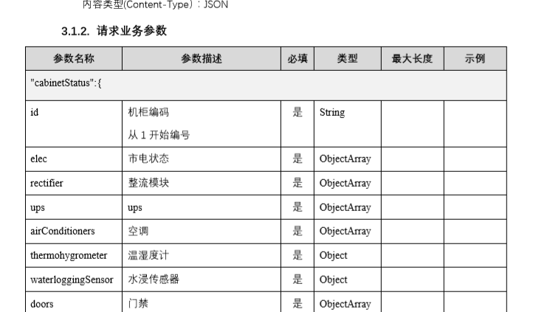

"elec":[

{

"id":"1",

"warningMsg":"系统电压: 53.6V (正常), 系统电流: 3.9 A (正常)",

"status":"1",

"outputCurrent":"3.92"

}

1. 空调上传数据不正确，两个空调系统采集数据正常，空调2systemWarning出现240数值不对，只有0和1两个状态。

该问题是主机采集或者空调问题，与ETC协议开发无关

isWorking运行状态，0待机;1运行 .

systemWarning系统告警0异常;1正常，

temperatureWarning温度告警0异常;1正常，

"airConditioners":[

{

"id":"1",

"warningMsg":"机柜温度: 28.0 °C",

"status":"1",

"isWorking":"0",

"systemWarning":"0",

"temperatureWarning":"0"

},

{

"id":"2",

"warningMsg":"机柜温度: 30.0 °C",

"status":"1",

"isWorking":"0",

"systemWarning":"240",

"temperatureWarning":"0"

}

1. 门禁状态不正确，系统采集状态显示为正常。

门禁上传是跟进金榜方式上传，但是主机dbcfg中数据未全部包含，门禁上传数据需修改

defendMode：布防模式 0 非 布防模式 1 布防模式。

frontDoorClosed：前门是否关门，0开门 1关门。

frontDoorLocked：前门门锁是否已锁，0打开 1已锁

frontDoorUnlockType：前门开锁类型，0门锁闭合 1刷卡解锁 2 远程控制解锁 3 钥匙解锁

frontDoorUnlockCardId：前门刷卡解锁时的卡号，无则填“NoData”

frontDoorOpenIllegally：前门是否非法开门,0合法开门或关门状态 1非法开门

frontDoorChangeTime：前门开关状态最后的变化时间

backDoorClosed：后门是否关门，0开门 1关门

backDoorLocked：后门门锁是否已锁，0打开 1已锁

backDoorUnlockType：后门开锁类型，0门锁闭合 1刷卡解锁 2 远程控制解锁 3 钥匙解锁

backDoorUnlockCardId：后门刷卡解锁时的卡号，无则填“NoData”

backDoorOpenIllegally：后门是否非法开门,0合法开门或关门状态 1非法开门

backDoorChangeTime：后门开关状态最后的变化时间

"doors":{

"status":"1",

"defendMode":"0",

"frontDoorClosed":"0",

"frontDoorLocked":"0",

"frontDoorUnlockType":"NoData",

"frontDoorUnlockCardId":"0",

"frontDoorOpenIllegally":"0",

"frontDoorChangeTime":"2020-03-17 17:07:54",

"backDoorClosed":"0",

"backDoorLocked":"0",

"backDoorUnlockType":"NoData",

"backDoorUnlockCardId":"0",

"backDoorOpenIllegally":"0",

"backDoorChangeTime":"2020-03-17 17:07:54"

},

1. 开关量设备烟雾和楼书告警状态值（isWarning）系统实际值与上传值相反

开关量设备需全部设为断开告警，0正常，1告警

烟雾正常状态，漏水告警状态

"waterloggingSensor":{

"isWarning":"0",

"warningChangeTime":"2020-03-18 10:32:42"

},

"smokeSensor":{

"isWarning":"1",

"warningChangeTime":"2020-03-18 10:32:42"

}

SmokeState=0WaterState=1烟雾正常漏水告警

"waterloggingSensor":{

"isWarning":"0", 实际1

"warningChangeTime":"2020-03-18 09:23:07"

},

"smokeSensor":{

"isWarning":"1", 实际0

"warningChangeTime":"2020-03-18 09:23:12"

}